
SPEAK ZED: AN INTERACTIVE PHRASEBOOK AND PRONUNCIATION GUIDE FOR ZAMBIAN LANGUAGES
PROJECT PROPOSAL
DEPARTMENT: Computer Science Department
Group Number: Group 19
Supervisor: Mrs. Z. Daka
Name | SIN
Kotati Mwaba | 23139927
Siyumbu Verspa | 23138356
Situmbeko Theodosius | 23129163
Chisamanga Prisca Chimwemwe | 23130383

Supervisor signature: …………………………
Abstract
Declaration
Acknowledgement
Contents
1. INTRODUCTION 1
1.1. BACKGROUND OF STUDY 1
1.2. PROBLEM STATEMENT 2
1.3. OBJECTIVE AND SPECIFIC OBJECTIVES 2
2. LITERATURE REVIEW 4
2.1. INTRODUCTION 4
2.2. RELATED WORKS 5
2.3. PREVIOUS SYSTEMS AND SIMILAR APPLICATIONS 8
2.4. Conclusion 18
3. RESEARCH METHODOLOGY 19
3.1. INTRODUCTION 19
3.2. METHODOLOGY 19
3.3. INFORMATION GATHERING AND ANALYSIS 19
3.4. REQUIREMENTS SPECIFICATION 25
3.4.1. FUNCTIONAL REQUIREMENTS 26
3.4.2. NON-FUNCTIONAL REQUIREMENTS 26
3.4.3. USER REQUIREMENTS 27
3.4.4. SYSTEM REQUIREMENTS 27
3.4.5. EXTERNAL INTERFACE REQUIREMENTS 28
3.4.6. CONSTRAINTS, LIMITATIONS AND ASSUMPTIONS 28
3.5. CONCLUSION 29
4. SYSTEM DESIGN 31
4.1. INTRODUCTION 31
4.2. ANALYSIS OF THE SYSTEM 31
4.3. CONTEXT DIAGRAM OF THE SYSTEM 33
4.4. DESIGN METHODS 33
4.5. PHYSICAL DESIGN 44
4.6. CONCLUSION 53

List of Figures
Figure 1: Screenshot of Jibbigo Mobile interface (Source: Jibbigo, 2010) 9
Figure 2: Screenshot of Beelinguapp 10
Figure 3: Screenshot of Aikuma 11
Figure 4: Screenshot of Duolingo 12
Figure 5: Screenshot of Pimsleur 13
Figure 6: Screenshot of Memrise 14
Figure 7: Screenshot of HelloTalk 15
Figure 8: Screenshot of TalkPal AI Language Learning Interface (Source: TalkPal AI: 2024) 16
Figure 9: Talk & Translate 17
Figure 10: Screenshot of Google Translate 18
Figure 11:Graph of Most Spoken Languages 21
Figure 12: Pie chart showing popularity of language barriers 22
Figure 13: Graph of important daily contexts 22
Figure 14: Graph of preferred features 23
Figure 15: Graph showing translation type 23
Figure 16: Context diagram of Speak Zed 33
Figure 17: Speak Zed Architectural Design 35
Figure 18: Level 0 Data-flow Diagram 36
Figure 19: Level 1 Data-flow Diagram for Quiz Module 37
Figure 20: Level 1 Data-flow Diagram for Manage Favorites Process 37
Figure 21: Use case Diagram for Speak Zed 38
Figure 22: Class Diagram for Speak Zed 39
Figure 23: Sequence Diagram for Audio Playback Process 40
Figure 24: Sequence Diagram for Search Phrase Function 41
Figure 25: Sequence Diagram for the Favorites feature 42
Figure 26: Sequence Diagram for the Phrasebook without the Search function 43
Figure 27: Sequence Diagram for the Quiz Module 44
Figure 28: Flow for the first few screens 45
Figure 29: Home screen of Speak Zed 46
Figure 30: Phrasebook and Categories screens 47
Figure 31: Translate Screen 48
Figure 32: Search Screen 48
Figure 33: Favorites Screen 49
Figure 34: Quiz Screen 49

List of Tables
Table 1: Structure of Phrase Data 51
Table 2: Structure of phrase data 52

INTRODUCTION

BACKGROUND OF STUDY
The integration of digital technology into everyday life has become increasingly important for communication, education, and access to essential services. In many countries, mobile applications and digital platforms are widely used to share information and support social and economic activities. However, the benefits of these technologies are not evenly distributed, particularly in developing countries where language diversity and limited infrastructure present significant challenges. Zambia is a multilingual country with numerous local languages that are widely spoken across different regions. While English serves as the official language, many people—especially those in rural and remote areas—primarily communicate using local languages. Despite this linguistic diversity, most digital technologies are designed using international languages, creating barriers for users who are not fluent in English. This limits their ability to effectively interact with digital systems and access important information. Additionally, internet connectivity in many parts of Zambia remains unreliable, making online dependent applications difficult to use. Existing translation and language-learning tools often provide limited support for Zambian languages and require constant internet access. These challenges highlight the need for a locally relevant, offline-capable digital solution that supports local languages. This project seeks to respond to this need by developing an accessible language support application tailored to the Zambian context. The rapid advancement of digital technology has transformed the way people communicate, learn, and access information and services. Mobile applications, websites, and digital platforms are now widely used in areas such as education, healthcare, business, and social interaction. Despite these developments, not all communities benefit equally from technology. In Zambia, language barriers continue to limit effective access to digital tools, particularly among individuals who are more fluent in local languages than in English. Zambia is a multilingual country with many local languages commonly used in everyday communication. Although English is the official language, a large portion of the population— especially in rural and remote areas—relies primarily on local languages. However, most digital applications and online services are developed using international languages, with English being the most dominant. This creates difficulties for users who struggle to understand and navigate technology due to limited English proficiency, resulting in reduced digital participation. The situation is more challenging in rural communities, where access to quality education, internet connectivity, and technological resources is often limited. People in these areas may find it difficult to remain technologically updated because digital platforms do not cater to their linguistic needs. This language gap restricts access to essential information and services, contributes to low digital literacy, and increases digital exclusion between urban and rural populations.
Current translation and language-learning technologies do not adequately address this issue. Many existing solutions focus on globally dominant languages and provide little support for Zambian languages. In addition, most of these applications depend on stable internet connectivity, which is unreliable or unavailable in many parts of the country. This makes them unsuitable for low resource environments and limits their effectiveness for users who need offline access. To address these challenges, this project proposes Speak Zed, an offline-first interactive phrasebook and pronunciation guide designed to support major Zambian languages. The application provides categorized everyday phrases, accurate translations, and text-to-speech functionality to assist with correct pronunciation. Additional features such as search, favorites, saved phrases, simple quiz modules, and review options enhance usability and learning. By prioritizing offline access and ease of use, Speak Zed aims to bridge the language gap between local people and technology, promote learning of both local languages and English, and improve digital inclusion in Zambia.

PROBLEM STATEMENT
The widespread use of digital technology has become essential for communication, education, and access to services in modern society. However, in Zambia, many people experience difficulties in using digital applications and platforms due to language barriers. Although the country has a rich diversity of local languages, most mobile applications, websites, and digital services are designed using international languages, particularly English. This creates challenges for users who are more familiar with local languages, limiting their ability to effectively interact with technology. The problem is especially evident in rural and remote areas, where English proficiency is often limited and access to technological resources is lower. Many individuals in these communities rely primarily on local languages for communication and learning. When digital systems do not support these languages, users struggle to understand content, navigate applications, and access important information. This results in reduced digital literacy, limited access to essential services, and increased digital exclusion, thereby widening the gap between urban and rural populations. Existing translation and language-learning applications do not sufficiently address this challenge. Most focus on globally dominant languages and offer little support for Zambian languages. In addition, many of these applications require constant internet connectivity, which is unreliable or unavailable in many parts of the country. As a result, such solutions are impractical for users in low-connectivity environments and fail to meet the needs of rural communities. Furthermore, many available tools lack proper pronunciation support, making it difficult for users to communicate effectively even when translations are provided. The absence of interactive features such as quizzes, saved content, and review options also limits learning effectiveness and long-term language retention. These limitations highlight the inadequacy of current solutions in addressing both communication and learning needs related to local languages. Therefore, there is a need for an accessible, offline-capable, and user-friendly digital solution that supports major Zambian languages. Such a solution should provide accurate translations, pronunciation guidance, and interactive learning features while remaining suitable for low-resource and low-connectivity environments. Addressing this problem is essential to improving digital inclusion and ensuring that more Zambians can benefit from modern technology.

OBJECTIVE AND SPECIFIC OBJECTIVES
- Main Objective
To design and develop an interactive pronunciation guide app to help Zambians learn and use local languages, promoting digital inclusion and breaking language barriers.
- Specific Objectives
- System objectives
- Design an easy-to-use app that works well even without the internet (offline feature).
- Implement a structured phrase database with categorized everyday phrases, accurate translations, and integrated native speaker audio pronunciations.
- Develop key user features like search, favorites, and interactive quizzes to enhance learning engagement.

- Functional Objectives
- Check if the app actually helps people in rural areas feel more confident using technology (get feedback, add review feature).
- The app should test users as a way of tracking their progress.

  - SCOPE OF STUDY
What the app WILL Do:
- Work with 3 major Zambian languages (Icibemba, Nyanja Tonga) and English
- Usable even without internet connectivity (includes download options and local app storage).
- For Zambians aged 13+ with limited English
- Include common daily phrases (for example, greetings, shopping, health).
- Mobile application
Development constraints:
- The app shall only be used inside Zambia to start with, specifically Riverside, Kitwe, Copper Belt.
- System shall take 7 months to develop and test.
- The app shall adhere to user privacy, data security, consent and budgetary constraints.
What the app WILL NOT do:
- It shall not offer full translation services
- It shall not teach full languages
- It shall not cover all Zambian languages for this project.

LITERATURE REVIEW

INTRODUCTION
Zambian major languages such as Bemba, Nyanja (also known as Chewa or Chinyanja), and Tonga are widely spoken across Zambia’s provinces, serving as essential mediums of everyday communication and cultural expression. However, despite the prevalence of these languages, they remain underrepresented in natural language processing (NLP) and speech technology research due to a severe scarcity of annotated datasets, computational models, and localized language infrastructure tailored to their linguistic characteristics. Low-resource languages such as these are often excluded from mainstream language datasets, which tend to focus on widely used global languages, creating a technological gap that impedes speech recognition, translation, and learning technologies for large segments of the Zambian population (Joshi et al., 2020).
Recent foundational work has begun to address this gap. For example, Zambezi Voice is an open-source multilingual speech corpus developed to support research on under-resourced Zambian languages. This dataset includes both labelled read speech and unlabeled audio across seven major native languages—including Bemba, Nyanja, and Tonga—and is designed to facilitate preliminary automatic speech recognition (ASR) and broader speech processing research via pretrained models such as Wav2Vec2.0. Complementary efforts like BembaSpeech, a 24.5-hour annotated ASR corpus for Bemba, further demonstrate the value and potential of targeted language resources to enable baseline ASR system training and evaluation for these languages. (Farouq et al., 2025), which presents early experimental results and should be considered preliminary research in the development of ASR systems for Bemba.
Across Africa, NLP research initiatives show that multilingual pretraining, community-driven data collection, and synthetic data augmentation are effective strategies for improving performance in low-resource settings. These approaches have been implemented in broader continental efforts—such as language dataset challenges and multilingual model projects—that aim to generate datasets and models for dozens or even hundreds of African languages. (Nekoto et al., 2020)
Despite these advances, existing resources remain largely research-oriented, with a predominant focus on ASR and TTS baselines rather than consumer-facing interactive language learning tools. Current mobile translation applications that include support for some Zambian languages typically deliver basic speech functionality but lack structured pronunciation guidance, retention-oriented pedagogical features, and robust offline usability tailored for local Bantu phonologies (e.g., noun class systems and tonality). (Joshi et al., 2020)
Compounding these technological limitations is Zambia’s enduring digital divide, which continues to restrict broad access to internet-dependent language technologies— especially in rural and underserved communities. A recent analysis of Zambia’s digital economy highlights that meaningful internet access and digital inclusion remain unevenly distributed, with significant disparities between urban and rural populations and persistent barriers to accessing digital services. (Joshi et al., 2020)
To bridge these linguistic and infrastructural gaps, we propose Speak Zed— an offline-first interactive phrasebook platform that integrates text-to-speech (TTS) pronunciation support and low-connectivity design principles for Zambia’s major languages. By emphasizing accessibility, usability, and long-term retention, Speak Zed aims to expand the reach of language technology beyond research prototypes to tangible tools for everyday learners and speakers in low-connectivity environments.

RELATED WORKS
This section reviews theoretical and empirical studies relevant to the development of Speak Zed. The review focuses on digital language learning, mobile-assisted language learning, low-resource languages in digital technology, offline mobile applications, phrase-based learning approaches, pronunciation support, and indigenous language preservation. Where appropriate, the discussion is contextualized using existing systems identified in the project proposal, without duplicating the detailed system analysis presented in Section 2.3.
    - Digital Language Learning
Digital language learning has evolved beyond traditional computer-assisted language learning (CALL) to incorporate mobile technologies, artificial intelligence, and multimedia-based instruction (Li & Lan, 2022). Modern platforms integrate gamification, instant feedback, and interactive content to enhance learner engagement and motivation.
Li and Lan (2022), in a review of 127 studies, report that digital language platforms improve learning flexibility, personalization, and engagement. However, they also identify cognitive overload and the digital divide as major challenges, particularly in low-resource environments. These limitations are evident in many mainstream applications such as Duolingo and Memrise, which assume consistent internet access and digitally literate users.
In Zambia, the digital divide remains significant. (Joshi et al., 2020) reports mobile phone penetration of 89.4%, while national internet penetration stands at 54.3%, dropping to approximately 31% in rural provinces. This supports the need for digital language tools that do not rely on continuous connectivity, a limitation observed in most global language learning platforms.
Implication for Speak Zed: Digital learning benefits must be retained while minimizing cognitive load and removing internet dependency.
    - Mobile-assisted Language Learning
Mobile-assisted language learning (MALL) leverages the portability and accessibility of mobile devices to support learning beyond traditional classroom settings. (Crompton & Burke, 2018), in a systematic review of 110 studies, found that mobile learning produces statistically significant learning gains, particularly for language learning applications.
In African contexts,(Porter et al., 2012) found that mobile phones are widely used for informal learning despite infrastructure constraints. However, shared device usage and high data costs limit the effectiveness of internet-dependent applications. This challenge is evident in platforms such as HelloTalk and Ningo AI, which rely on real-time interaction and online AI services.
UNESCO studies on mobile reading (West & Chew, 2014) emphasize that successful mobile learning systems in developing contexts must be offline-capable, lightweight, and culturally relevant—criteria not fully met by most mainstream MALL applications.
Implication for Speak Zed: The system must support mobile learning while remaining usable on shared devices and in low-connectivity environments.

    - Low-resource Languages in Digital Technology
Low-resource languages such as Bemba, Nyanja, and Tonga present several technical challenges for natural language processing and speech technologies. These languages are tonal, meaning that differences in pitch or tone can change the meaning of words even when the spelling remains the same. This characteristic complicates automatic speech recognition and text-to-speech systems, as models must correctly identify tonal variations to produce accurate outputs. In addition, many Bantu languages employ complex noun class systems in which prefixes determine grammatical agreement across verbs, adjectives, and pronouns. This morphological structure increases the number of possible word forms that computational models must process, making traditional NLP approaches more difficult to implement effectively. Data scarcity further intensifies these challenges. While widely used languages such as English have billions of annotated words and speech recordings available for training machine learning systems, many African languages have only small experimental datasets. Consequently, researchers often adopt alternative strategies such as curated phrase-based resources, community-driven data collection, and native-speaker audio recordings to create practical language tools in low-resource environments.
Low-resource languages face systematic exclusion from language technologies due to lack of data, funding, and standardization. (Joshi et al., 2020) found that over 87% of NLP research focuses on English, leaving thousands of languages underserved.
African languages are particularly affected (Nekoto et al., 2020) report that fewer than 30 African languages have any meaningful machine translation resources. Applications such as Google Translate, Talk & Translate, and Jibbigo perform poorly for many African languages due to tonal systems, agglutinative morphology, and limited training data.
Although languages such as Bemba, Nyanja, and Tonga have millions of speakers(The Mobile Economy 2023 | GSMA Intelligence, 2023) (Eberhard et al., 2024), they lack robust NLP infrastructure. This makes advanced AI-based translation and speech recognition impractical for undergraduate-level systems.
Implication for Speak Zed: A curated, phrase-based approach with native speaker validation is more feasible and reliable than AI-driven translation.
    - Offline Mobile Applications in Low-connectivity Contexts
Offline-first design is essential in environments with unreliable connectivity. GSMA (2023) reports that 1GB of mobile data in Sub-Saharan Africa costs approximately 3.4% of average monthly income, making continuous internet usage unsustainable.
ZICTA (2023) further reports that rural Zambian users experience frequent network outages and limited broadband coverage. While some applications such as Google Translate and Jibbigo offer partial offline functionality, most still rely on online updates or cloud-based processing.
Talk & Translate provides rapid speech and text translation between multiple languages using cloud-based processing and real-time communication features. While this functionality is useful for travelers or quick interactions, the system is primarily designed for translation rather than structured language learning. In addition, its reliance on internet connectivity and machine translation limits its effectiveness in environments with poor connectivity or when handling low-resource languages that lack sufficient training data. These limitations highlight the importance of alternative approaches such as curated phrase-based learning and offline functionality, both of which form the foundation of the Speak Zed system.
Google Developers (2020) emphasize that offline-first design improves reliability, usability, and user trust. These principles are particularly relevant for educational tools intended for underserved communities.
Implication for Speak Zed: All core learning features must function fully offline, with online access treated as optional enhancement rather than a requirement.

    - Phrase-based Learning Approach
Phrase-based learning emphasizes acquiring formulaic sequences rather than isolated vocabulary or grammar rules. Schmitt and Carter (2004) show that formulaic language accounts for up to 50% of natural language use, enabling faster and more fluent communication.
Nation demonstrates that vocabulary learned in meaningful phrasal contexts shows significantly higher retention than isolated word learning. Audio-first systems such as Pimsleur adopt this approach successfully but focus on conversational fluency rather than localized, culturally specific usage.
Phrasebooks embedded in applications like Google Translate provide functional expressions but lack structured learning progression and cultural grounding.
Implication for Speak Zed: Organizing content around everyday phrases supports immediate functional communication, particularly for beginners.
    - Pronunciation Support and Audio-based Learning
Pronunciation is critical for intelligibility, especially in tonal languages. Foote and McDonough (2017) demonstrate that repeated exposure to native speaker audio significantly improves pronunciation accuracy. Cardoso (2018) further shows that native speaker recordings outperform synthetic speech, particularly for tonal and phonologically complex languages.
Many existing systems, including Duolingo and Memrise, rely heavily on synthetic text-to-speech, which performs poorly for low-resource languages. While Pimsleur emphasizes audio, it lacks coverage for Zambian languages.
Implication for Speak Zed: Native speaker audio is essential for accurate pronunciation learning in Bemba, Nyanja, and Tonga
    - Indigenous Language Preservation Through Technology
Digital tools can support indigenous language preservation when designed with local relevance. Bird (2020) argues that language technologies should prioritize community benefit and accessibility rather than technological complexity.
Applications such as Aikuma demonstrate how mobile technology can support indigenous languages through audio, but focus primarily on documentation rather than learning. Speak Zed complements such efforts by promoting active language use and learning rather than preservation alone.
Implication for Speak Zed: Language technology should support both cultural preservation and everyday communication.
    - Summary and Link to Proposed System
The literature shows that while many existing systems support language learning, translation, or pronunciation, most focus on global languages, require consistent internet access, or rely on complex AI models unsuitable for low-resource contexts. Systems identified in the project proposal each address parts of the problem but fail to holistically support offline, culturally relevant learning for Zambian languages.
Speak Zed addresses these gaps by combining offline-first design, phrase-based learning, and native speaker pronunciation support tailored to selected Zambian languages, providing a feasible and context-appropriate solution.

PREVIOUS SYSTEMS AND SIMILAR APPLICATIONS
This section analyzes ten existing applications related to language learning, translation, phrasebooks, and pronunciation support. These systems share certain features with Speak Zed but also exhibit limitations in offline accessibility, support for low-resource languages, culturally contextual phrase learning, and structured pronunciation training. Each system is discussed in terms of purpose, features, usage statistics, platform availability, and relevance to the proposed system.
    - Jibbigo
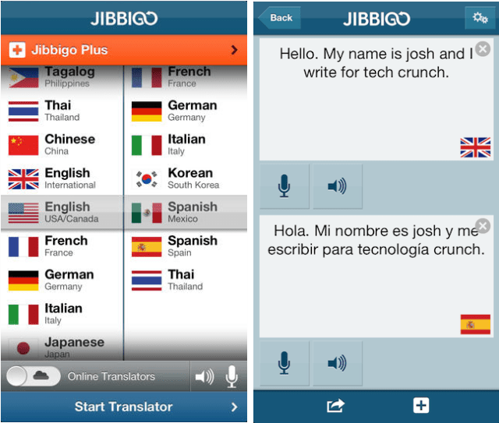
Figure 1: Screenshot of Jibbigo Mobile interface (Source: Jibbigo, 2010)
The screenshot shows a simple speech input button, language selection dropdowns, and translated text output displayed beneath the microphone interface.
Platform: Android, iOS
License: Free (discontinued)
Languages Supported: ~25 major languages (historical data)
Users/Downloads: Not publicly available (acquired by Facebook in 2013)
URL (Archived Info): https://en.wikipedia.org/wiki/Jibbigo
Jibbigo was one of the first offline speech-to-speech translation apps. It enabled users to speak into their device and receive translated speech without internet connectivity.
Key Features:
Offline speech translation
Text and audio output
Downloadable language packs
Built-in dictionary
Relevance to Speak Zed:
Although Jibbigo supported offline functionality similar to Speak Zed, it focused on translation rather than structured learning. It did not support Zambian languages or culturally contextual phrase sets.
    - Beelinguapp
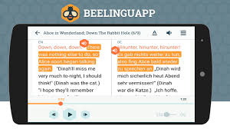
Figure 2: Screenshot of Beelinguapp
The screenshot displays bilingual side-by-side text, with highlighted sentences synchronized to audio narration.
Platform: Android, iOS
License: Freemium
Languages Supported: 14+ languages
Downloads: 5+ million (Google Play Store)
URL: https://www.beelinguapp.com
Beelinguapp teaches languages through parallel texts and audio narration.
Key Features:
Dual-language text display
Audio narration
Highlighted text tracking
Story-based learning
Relevance:
Pimsleur’s audio-first methodology emphasizes listening and repetition as the primary mechanisms for language acquisition. Learners are exposed to carefully structured conversational phrases and are encouraged to repeat and recall them at spaced intervals, reinforcing pronunciation and long-term memory retention. This focus on pronunciation and spoken communication aligns closely with the goals of Speak Zed, which also prioritizes native-speaker audio and practical communication. However, Pimsleur primarily targets widely spoken global languages and operates through a paid subscription model, which limits accessibility in many low-resource environments. Additionally, the platform does not include Zambian languages such as Bemba, Nyanja, or Tonga. As a result, while Pimsleur demonstrates the effectiveness of audio-driven learning approaches, Speak Zed aims to apply similar principles within a localized, culturally relevant, and offline-accessible system.
While both Beelinguapp and Speak Zed integrate audio and text, Beelinguapp emphasizes reading comprehension rather than practical conversational phrases. It also depends heavily on internet access.
    - Aikuma
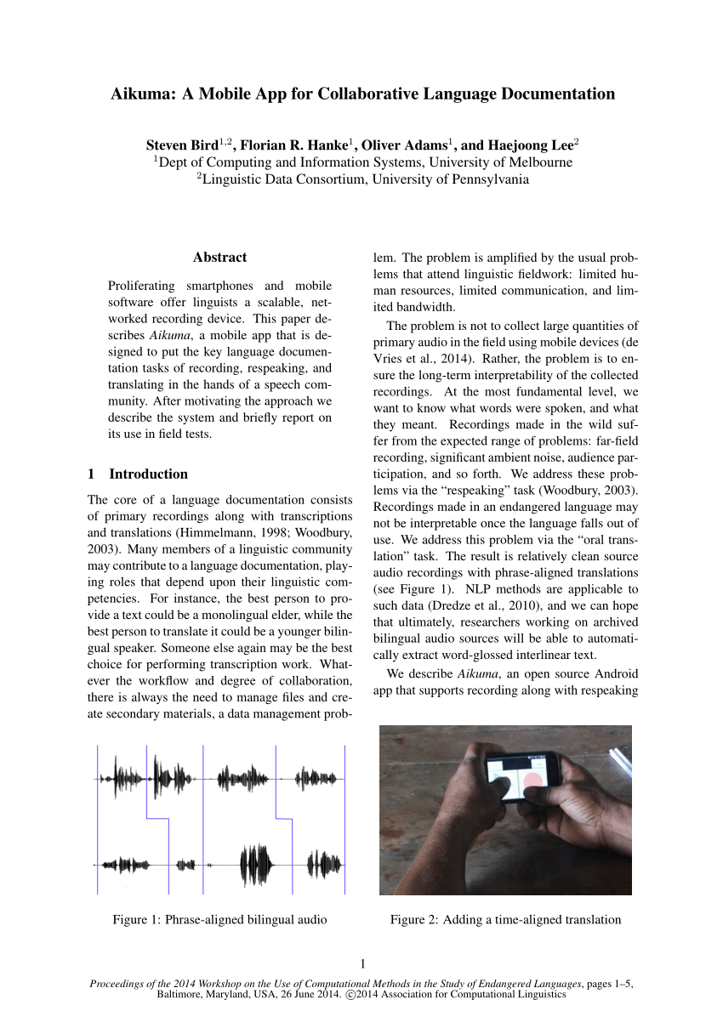
Figure 3: Screenshot of Aikuma
The screenshot shows a recording interface with waveform visualization and playback controls.
Platform: Android
License: Open source
Languages: Unlimited (user-recorded)
Downloads: 10,000+
URL: https://aikuma.org
Aikuma is designed for recording and documenting endangered languages.
Key Features:
Audio recording
Time-aligned translation
Simple interface
Collaborative speech collection
Relevance:
Unlike Speak Zed, Aikuma does not provide structured lessons or phrase-based learning.
    - Duolingo
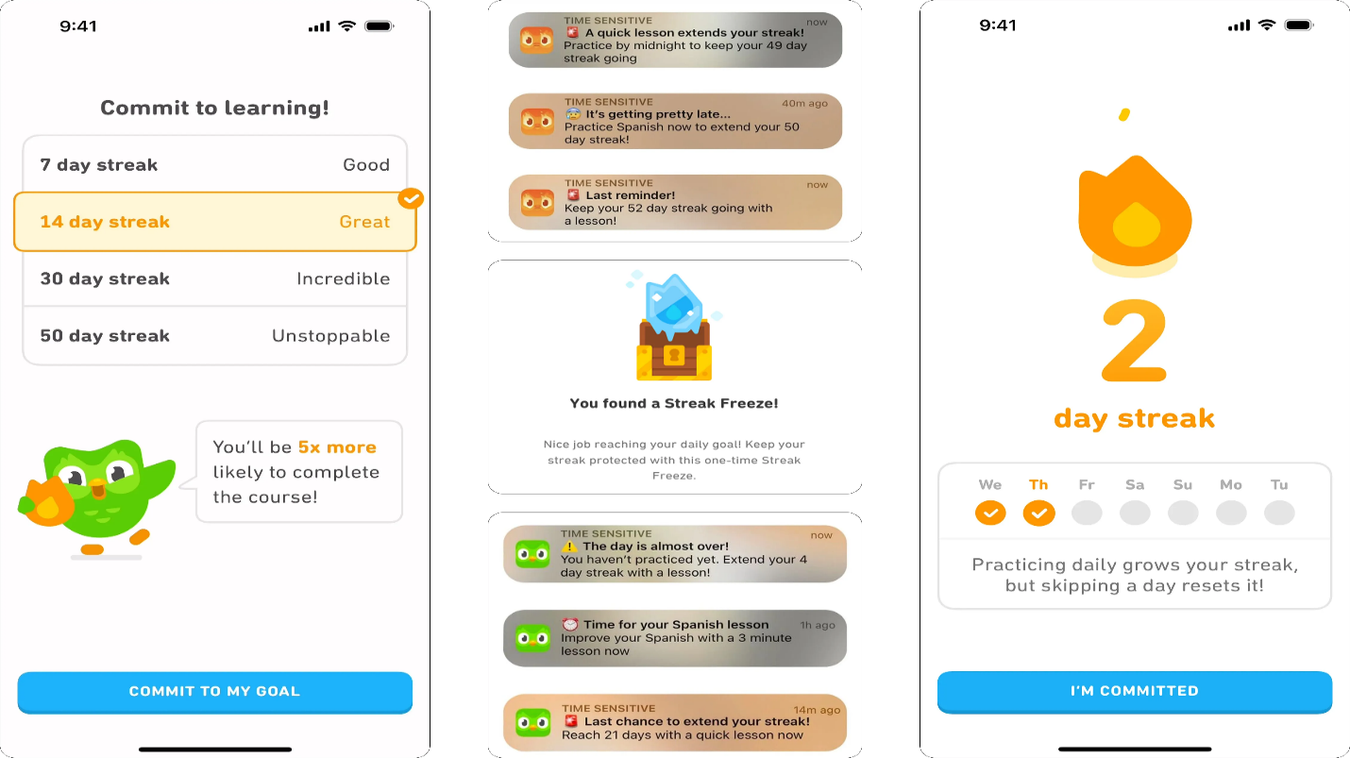
Figure 4: Screenshot of Duolingo
The screenshot shows a colorful gamified interface with XP points, hearts (lives), and multiple-choice exercises.
Platform: Android, iOS, Web
License: Freemium
Languages Supported: 40+
Users: 500+ million registered users
URL: https://www.duolingo.com
Duolingo provides structured lessons with gamification elements.
Key Features:
- Grammar exercises
- Listening and speaking practice
- Streaks and rewards
- AI-based personalization
Relevance:
Duolingo supports many languages but does not include Zambian local languages. It also requires internet connectivity for most features.
    - Pimsleur
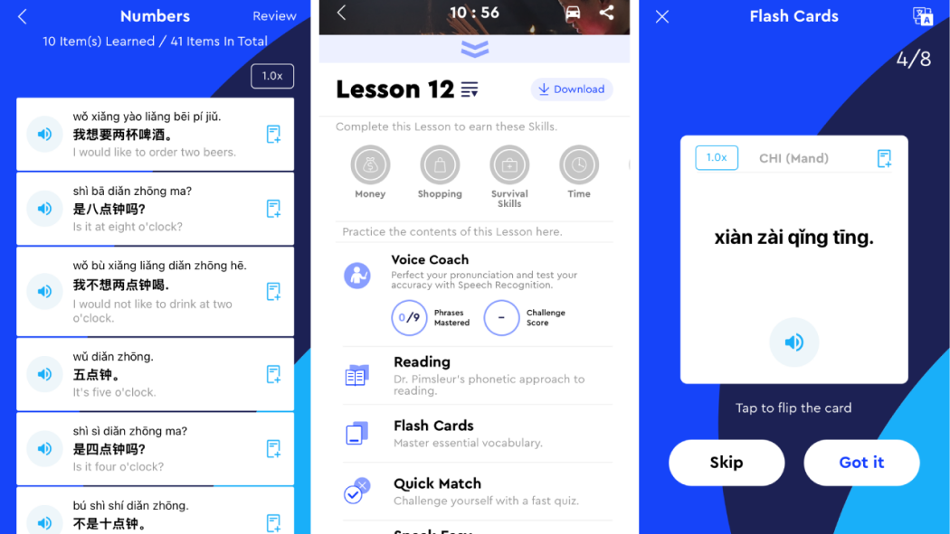
Figure 5: Screenshot of Pimsleur
The screenshot shows audio lesson playback with progress tracking and lesson navigation.
Platform: Android, iOS
License: Paid subscription
Languages Supported: 50+
Users: Not publicly disclosed
URL: https://www.pimsleur.com
Pimsleur focuses on conversational fluency through structured audio lessons.
Relevance:
Although pronunciation-focused like Speak Zed, Pimsleur is subscription-based and does not support Zambian languages.
    - Memrise
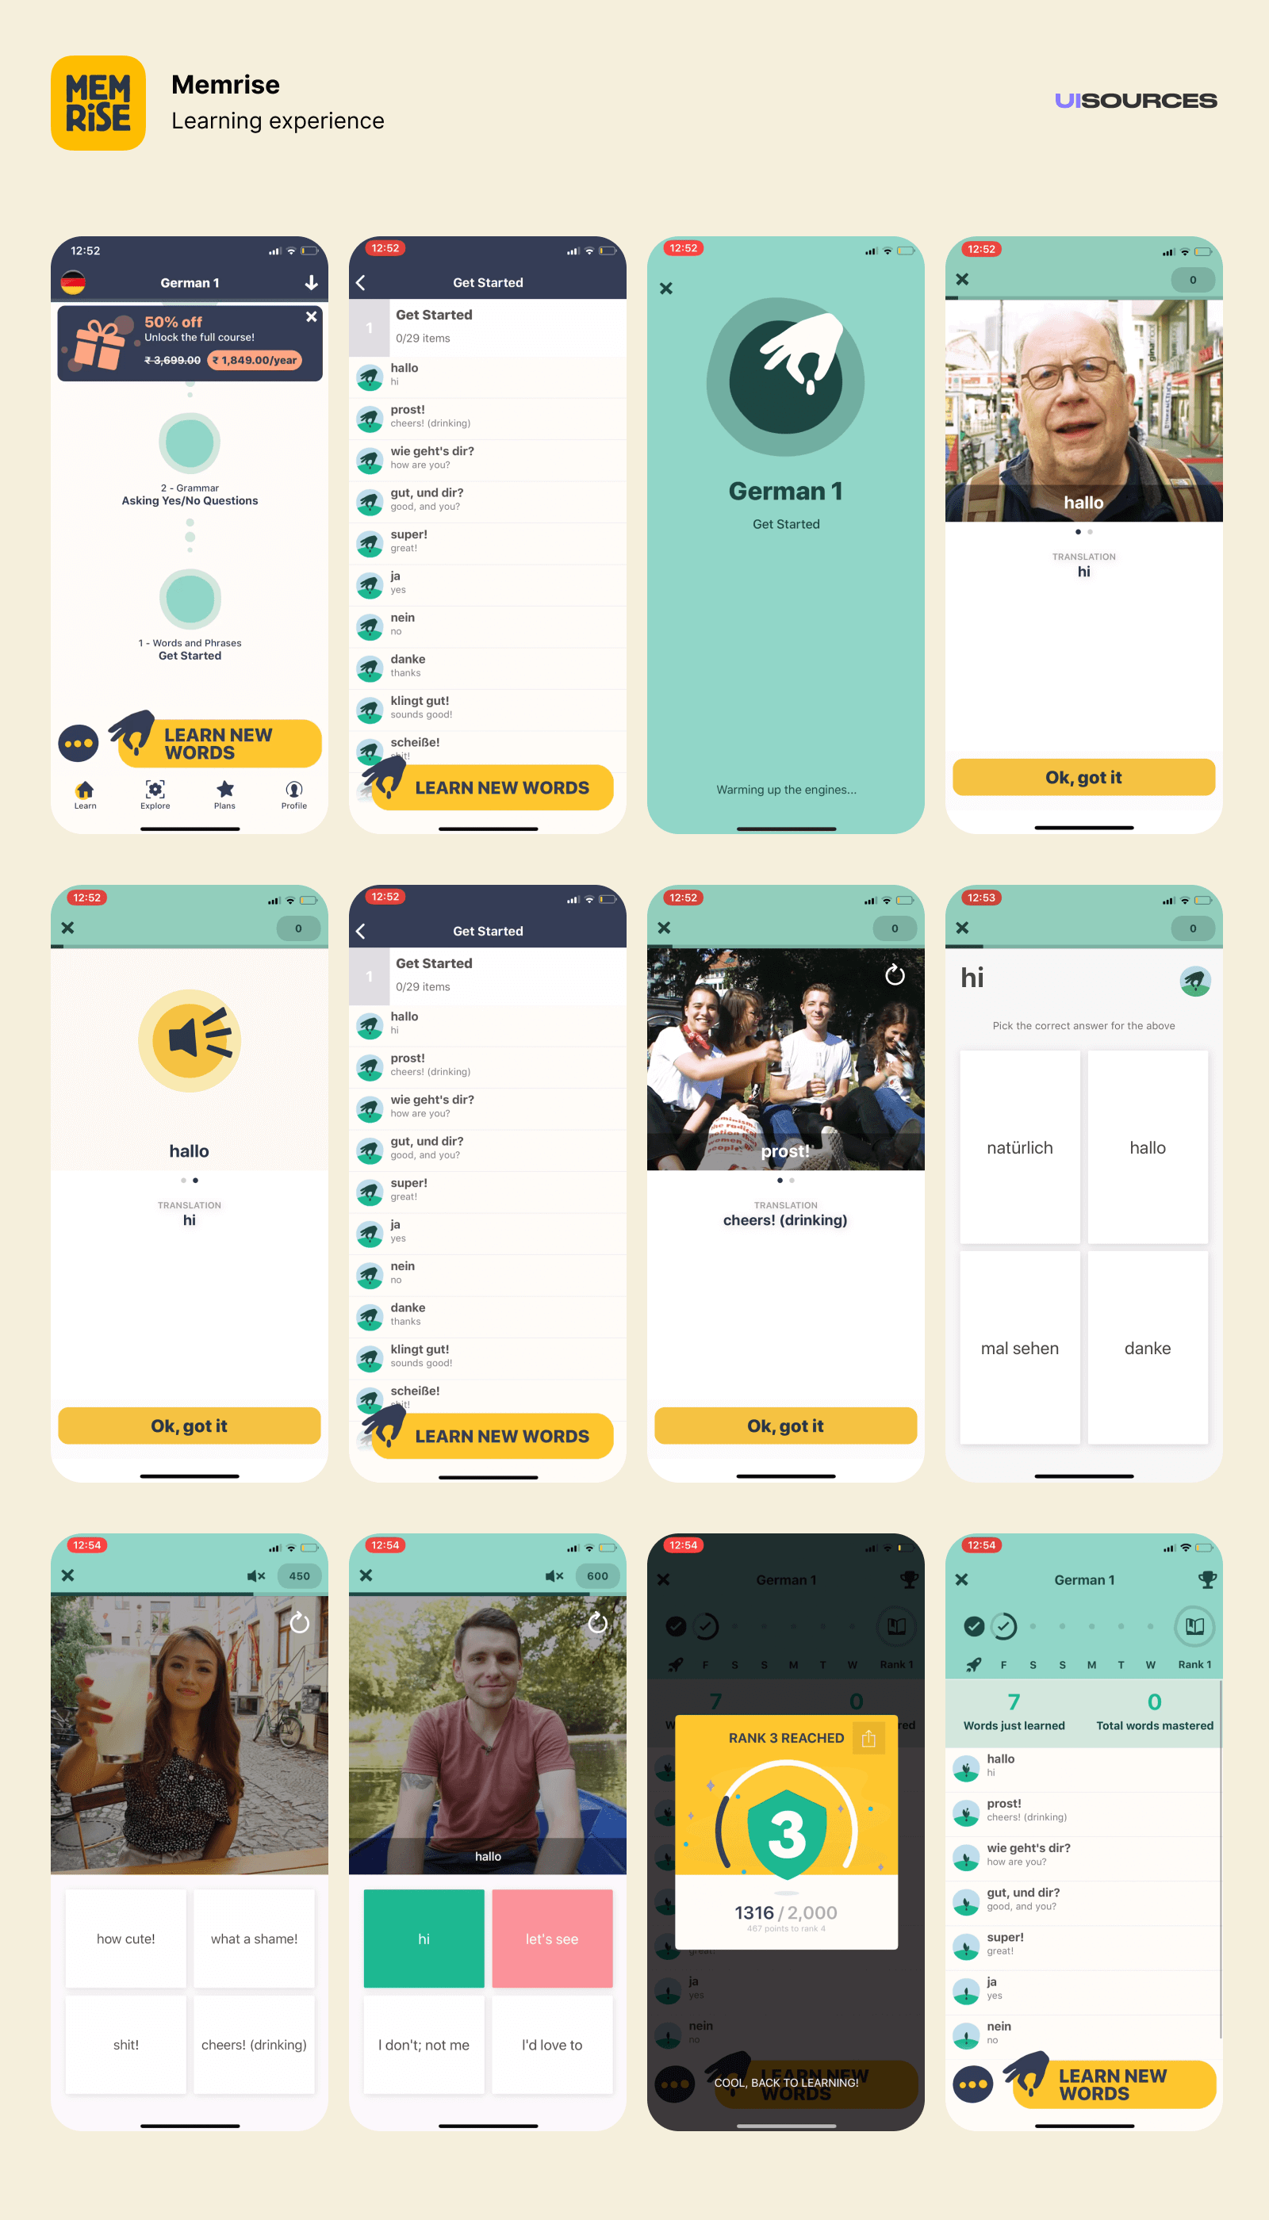
Figure 6: Screenshot of Memrise
The screenshot shows flashcards with multiple-choice vocabulary options.
Platform: Android, iOS, Web
License: Freemium
Languages Supported: 20+ official courses
Downloads: 50+ million
URL: https://www.memrise.com
Memrise uses spaced repetition and mnemonic memory aids.
Relevance:
Memrise supports vocabulary learning but is internet-dependent and lacks localized Zambian language courses.
    - HelloTalk
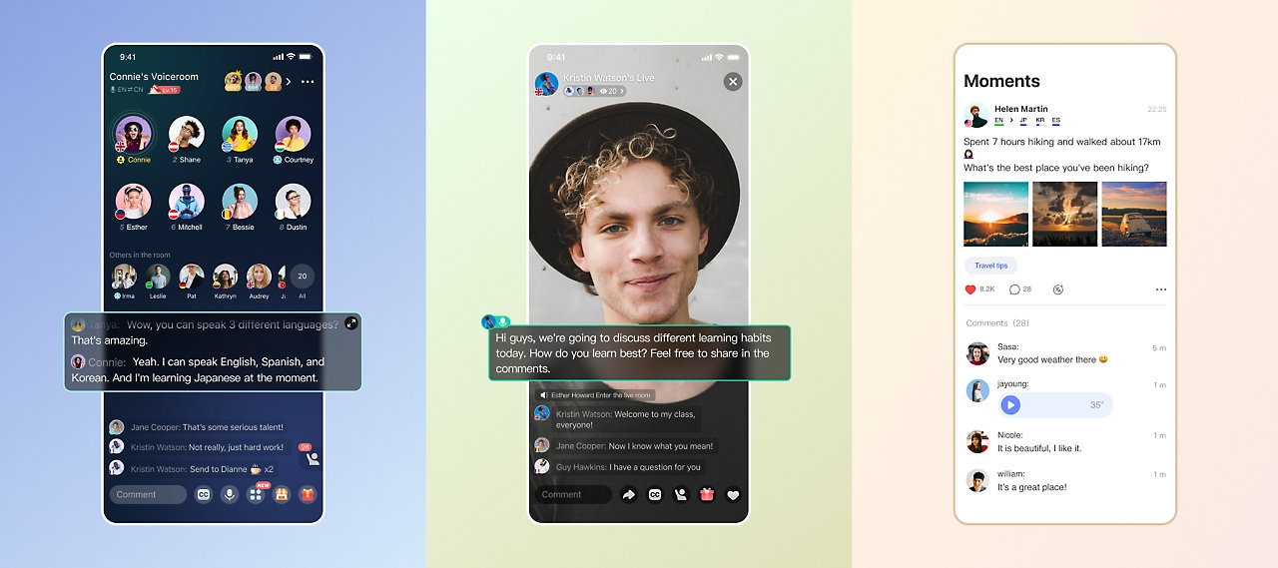
Figure 7: Screenshot of HelloTalk
The screenshot shows a messaging interface with translation assistance features.
Platform: Android, iOS
License: Freemium
Users: 30+ million
URL: https://www.hellotalk.com
HelloTalk connects learners with native speakers.
Relevance:
Unlike Speak Zed, it requires real-time interaction and internet connectivity.
    - TalkPal AI
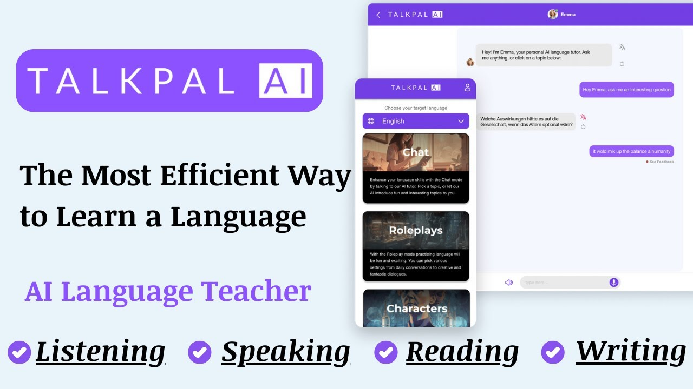
Figure 8: Screenshot of TalkPal AI Language Learning Interface (Source: TalkPal AI: 2024)
The screenshot shows an AI chatbot-style interface where users interact conversationally with an AI tutor, receiving grammar corrections and pronunciation guidance.
Platform: Android, iOS, Web
License: Freemium (premium subscription available)
Languages Supported: 55+
Downloads: 1M+ (Google Play Store)
URL: https://talkpal.ai
Talkpal AI is an AI-driven language learning platform that provides conversational tutoring using artificial intelligence. The system simulates real-time conversations and provides grammar correction, vocabulary suggestions, and pronunciation feedback.
Key Features:
AI conversational tutor
Real-time grammar correction
Speech recognition
Personalized learning pathways
Progress tracking
Relevance to Speak Zed:
Talkpal AI demonstrates how AI can enhance language learning through interactive dialogue. However, it relies entirely on internet connectivity and cloud-based processing. Additionally, it does not support Zambian local languages. In contrast, Speak Zed avoids heavy AI dependency and prioritizes offline-first functionality for low-connectivity environments.
    - Talk & Translate
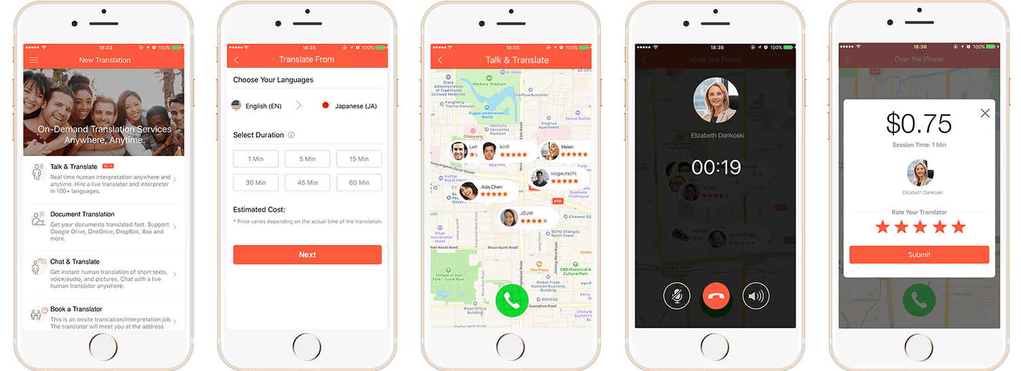
Figure 9: Talk & Translate
The screenshots show how the app helps people connect with real translators quickly through their phone.
Platform: Android, iOS
Downloads: 10+ million (varies by developer)
URL: https://play.google.com
Provides quick speech and text translation.
Relevance:
Primarily translation-focused, not structured learning-based.
    - Google Translate
The screenshot shows Google translate app page in the App Store.
Platform: Android, iOS, Web
License: Free
Languages Supported: 130+
Downloads: 1+ billion
URL: https://translate.google.com
Provides neural machine translation with offline packs.
Relevance:
Although powerful, translation accuracy for low-resource languages is limited. It does not provide structured phrase-based learning tailored to Zambian cultural contexts.
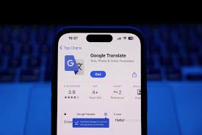
Figure 10: Screenshot of Google Translate

Conclusion
The reviewed systems demonstrate significant innovation in translation, gamification, AI tutoring, and social language exchange. However, none combine all of the following critical requirements:
Offline accessibility on low-end Android devices, with essential features available without internet connectivity.
Practical, everyday phrase-based learning, structured for immediate functional communication.
Native speaker pronunciation support, particularly for tonal and under-documented languages.
Explicit support for Zambian local languages, including Bemba, Nyanja, and Tonga.
Cultural contextualization, ensuring that phrases reflect real-life local communication needs.
While systems such as Duolingo and Memrise offer structured learning, they require consistent connectivity and do not support Zambian languages. Translation tools such as Google Translate provide offline packs but prioritize machine translation over structured learning. AI-based platforms like Talkpal AI enhance interactivity but depend on continuous internet access and high computational resources.
Speak Zed addresses this identified gap by adopting an offline-first architecture, ensuring that core features — phrase browsing, native audio playback, and structured practice — function without internet connectivity. Although some optional features may require online access (such as updates or synchronization), the primary learning functionality remains accessible offline, making the system suitable for low-connectivity environments.

RESEARCH METHODOLOGY

INTRODUCTION
This section defines, describes, and justifies the design approaches and data collection methodologies used in the development of the proposed system. The design approaches focus on the different perspectives considered during system development and how the system architecture and functionality were structured to address these perspectives.
The data collection methodologies focus primarily on requirements elicitation, analysis, and partial validation. Since the system follows an agile-oriented development approach, requirements may evolve over time as additional insights are obtained during development.
These methodologies demonstrate that the system requirements were not solely based on assumptions but were instead derived from research and feedback gathered from potential users. This ensures that the requirements are relevant and appropriate for the target users specified within the project scope outlined in the project proposal.

METHODOLOGY
This project adopts a hybrid system design approach that combines structured analysis and object-oriented design methodologies. Structured analysis techniques such as Data Flow Diagrams are used to understand the system processes and the movement of data within the application. Object-oriented design techniques are then applied to model system components as classes and objects, which aligns with the Flutter framework and the Dart programming language used to implement the system. This hybrid approach provides both a clear understanding of system functionality and an effective structure for system implementation.

INFORMATION GATHERING AND ANALYSIS
To ensure that the proposed system addresses real user needs and existing limitations in similar solutions, several data collection methods were employed. These methods helped identify system requirements, user expectations, and potential improvements for the proposed system.
    - Literature Review Existing Systems
A review of similar systems was conducted as part of the literature review. Academic and online sources such as Google Scholar, Wikipedia, and other relevant web resources were used to study existing language learning and translation systems.
The literature review helped identify:
- Features currently implemented in similar systems
- Limitations present in existing solutions
- Opportunities for improvement in the proposed system
These insights helped shape the requirements of the proposed system by highlighting areas where improvements could be made, particularly in addressing challenges related to language barriers and accessibility.
For reference management and citation tracking, the tool Zotero was used. This helped organize academic sources and maintain accurate references throughout the research process.

    - Questionnaires Distributed to Local Participants
A questionnaire was designed and printed for physical distribution to members of the local community. Approximately forty respondents participated in this survey.
The purpose of this questionnaire was to collect feedback from individuals who frequently interact using local languages. The responses helped identify user expectations, challenges in communication, and preferences related to system usability. In particular, the feedback provided insights into:
- User interface preferences
- Ease of interaction with technology
- Practical challenges faced when communicating across languages
This information was important for defining user interface and user experience requirements.
20 questionnaires were distributed and out of the 20, only 18 respondents gave feedback. Out of the 18, 15 knew a mixture of local languages and English but the higher majority claimed to be more fluent in local languages. When asked what additional features they would love in the app, 17 responded with a request for audio features and 2 responded with a request for a clean and simple layout of the user interface. When asked what difficulties they face when interacting with people like students or officials who are more fluent in global languages, 11 claimed a language barrier, especially with understanding certain terms in the other language and 1 responded with difficulty in fluency, which was interpreted as improper pronunciation and use of words in the other language and the remaining 6 did not fill in that section.
Speak Zed satisfies these needs in the following ways. Audio features are already part of the early designs of Speak Zed so the users need not worry about that aspect. A simple user interface was intended as the inspiring audience is people with minimal digital literacy and semi-literate users. The difficulties faced further support Speak Zeds features. For example, poor fluency is combated by the audio pronunciation guide feature and quiz feature that reinforces learning. Categories also help users know when to use particular phrases which reduces misunderstandings.
    - Online Survey Using Google Forms
An online survey was created using Google Forms and distributed among fellow students.
This group represented users who are less familiar with local languages but generally more comfortable using digital platforms. Unlike the local participants, these users experience fewer issues related to internet access or digital literacy.
Feedback from this group focused mainly on:
- Features that would improve the usefulness of the system
- Suggestions based on experience with other language learning or translation applications
- Recommendations for improving functionality and usability
This helped identify additional system features and enhancements that could make the system more practical for users who need assistance communicating in local languages.
Below are the statistical representations of the responses received. A minimum of 20 responses was agreed upon and 22 responses were received.
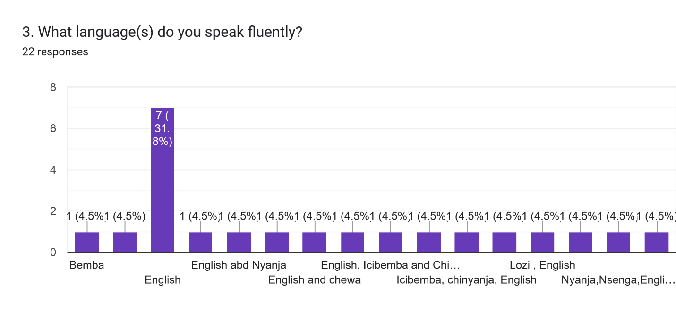
Figure 11:Graph of Most Spoken Languages
Figure 1 graph above proves the assumption that the majority of this group is unfamiliar with local languages. This means that including this group as part of the audience was a realistic move because while the inspiration focuses on those in remote areas who are unfamiliar with global languages, communication is a two-way activity occurring daily.
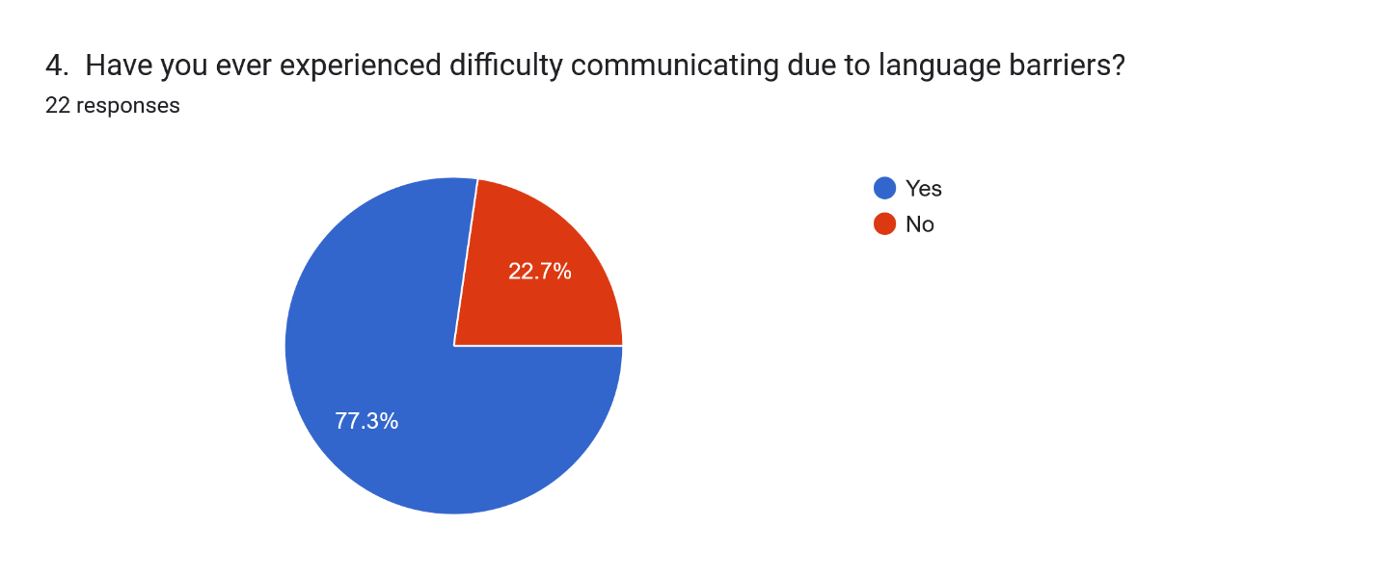
Figure 12: Pie chart showing popularity of language barriers
The pie chart in figure 2 gives importance to Speak Zed’s motive as it proves that language barriers are in fact a common issue. Logically speaking, even the 27% that said no was only speaking based off of their current location. Depending on where one is, they may face different language barriers. For example, institutions like universities comprise of people from various provinces, or even countries, so those who are not locals of the area may have a higher chance of experiencing language barriers.
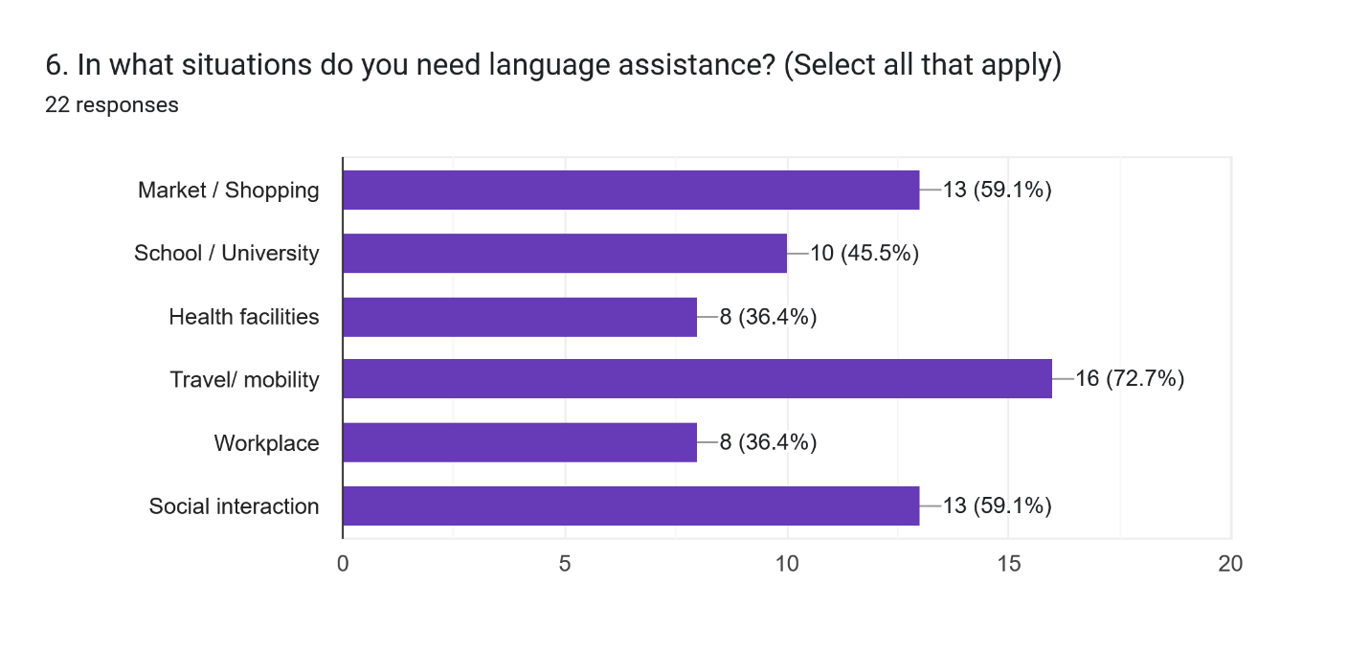
Figure 13: Graph of important daily contexts
Speak Zed is designed with a categorized phrasebook. The categories represent the many contexts where language barrier may occur on a daily basis. The graph in figure 3 listed a few of the most important situations daily communication may encompass and the responses show the most popular, which adds to the priority categories to be included in Speak Zed’s early iterations. From the graph, we notice that travel/mobility, social interaction and market/shopping are the most popular situations in which bi-lingual communication is important.
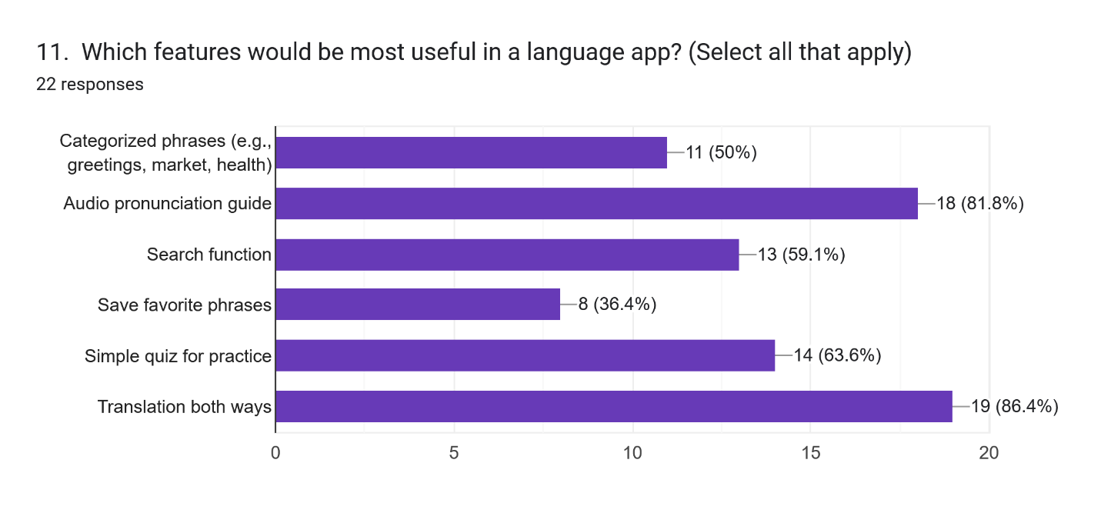
Figure 14: Graph of preferred features
Focusing on the top three features, the graph in figure 4 shows the translation both ways, audio pronunciation guide and quiz features as the most preferred. Speak Zed adopts a bilingual type of translation that allows users to translate to and from any two languages. The audio pronunciation guide shows almost as much importance as the struggle to read in other languages is more common than acknowledged. Even though Speak Zed is designed to be used for instant practical translation and use, it does not ignore the learning aspect. The quiz module was added to enforce learning and according to the graph, this feature is just as important in the long run.
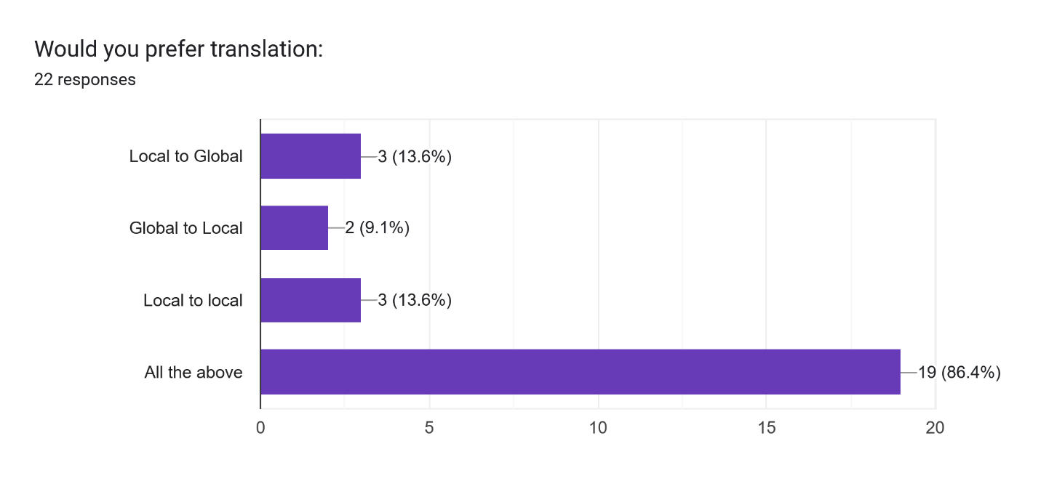
Figure 15: Graph showing translation type
The graph in figure 5 shows that even though translation is not just about global versus local languages. The majority of the respondents voted, “All the above” because sometimes, a local-to-local translation is needed, other times, a local-to-global and other times a global-to-local translation. This promotes Speak Zed’s bilingual translation feature that allows translation from any two languages, whether they are both local languages or one of them is a global language.
Initially, English is the only global language supported by Speak Zed as it is the dominating global language in Zambia, and generally in other countries. Therefore, a global-global type of translation is not of priority for Speak Zed’s current objective.
The potential users were asked for any additional feature and amongst their responses, the following caught the eye of the development team:
- An app streak to promote consistency
- Interactions with tutors on the platform
- Audio and video features
- Being able to select the level you would like to start with learning
- Making the app accessible everywhere
- App reminders
- Audio and Verbal features
Response 1 and 6 have similar aims, the developers opted for a streak feature implemented in the quiz module that tracks frequency of practice. Response 2 is a great idea but does not prioritize Speak Zed’s objective of practical use and was not accepted as a necessary implementation for early versions of Speak Zed. Response 3 is partially already implemented as audio features are a primary feature of Speak Zed but video features are not. This is also because video features do not prioritize the use Speak Zed’s objective and most language learning apps in general. Speak Zed developers implement the idea of response 4 in the quiz module. When a user initiates a quiz, they are first prompted for the language, category and difficulty level and a quiz is generated based on this information. Response 5 is reasonable but currently not feasible for the scope of Speak Zed due to limited time constraints and costs of deployment. Speak Zed developers omitted verbal features by switching from traditional text-to-speech to audio pronunciation guide. While users may hear how words are pronounced, they are unable to confirm their pronunciation using the app in regards to early versions of Speak Zed.
    - Developer-Driven Requirements
In the early stages of development, several initial system requirements were generated by the developers. These requirements were based on the overall vision of solving communication challenges between individuals who speak different languages.
This developer-driven approach helped establish the foundational functionality of the system before further refinement through user feedback and research. The requirements were later validated and improved through insights gathered from the literature review, questionnaires, and online surveys.

REQUIREMENTS SPECIFICATION
This section specifies the functional and non-functional requirements of the Speak Zed mobile application. It serves as a reference for system design, implementation, and testing.
Speak Zed is a mobile-based, offline-first phrasebook application designed to help users learn and correctly pronounce common phrases in selected Zambian languages (Bemba, Nyanja, Tonga, and Lozi). The system focuses on pronunciation support and basic language learning rather than full sentence translation.
- Terminology
Offline-first: The application functions without internet access.
Phrasebook: A collection of commonly used phrases categorized by context.
Pronunciation audio: Recorded audio clips spoken by native speakers.
Hive: A lightweight local storage solution for Flutter.
- Product Perspective
Speak Zed is a standalone mobile application developed using the Flutter framework. It does not rely on a remote server and stores all data locally on the user’s device.
- Product Functions (High-Level)
Display categorized phrases
Play pronunciation audio
Search for phrases
Save favorite phrases
Provide simple quizzes for learning reinforcement
Operate fully offline
- User Characteristics
General users with basic smartphone literacy
No prior technical knowledge required
Users may have limited internet access
- Operating Environment
Android mobile devices
Android version 8.0 and above
Touchscreen interface
- Constraints
Limited development time (7 months)
No real-time machine translation
Local storage only (no cloud services)
- Assumptions and Dependencies
Users have access to an Android smartphone
Audio files are pre-recorded and bundled with the app.

FUNCTIONAL REQUIREMENTS
- Phrasebook Management
FR-01: The system shall display phrases grouped into predefined categories.
FR-02: The system shall display phrases in both English and the selected local language.
FR-03: The system shall allow users to select a language to view phrases.
- Pronunciation Support
FR-04: The system shall allow users to play pronunciation audio for each phrase.
FR-05: The system shall allow users to replay pronunciation audio.
- Search and Favorites
FR-06: The system shall allow users to search for phrases using keywords.
FR-07: The system shall allow users to save phrases as favorites.
FR-08: The system shall allow users to view saved favorite phrases.
- Quiz Module
FR-09: The system shall provide multiple-choice quiz questions based on stored phrases.
FR-10: The system shall display feedback indicating whether an answer is correct or incorrect.
- Offline Functionality
FR-11: The system shall operate without internet connectivity.

NON-FUNCTIONAL REQUIREMENTS
- Usability
NFR-01: The system shall have a simple and intuitive user interface.
NFR-02: The system shall be usable by first-time users without training.
- Performance
NFR-03: The system shall load phrase lists within 2 seconds on average devices.
NFR-04: Audio playback shall start within 1 second of user interaction.
- Reliability
NFR-05: The system shall retain user favorites after application restart.
- Portability
NFR-06: The system shall be installable on Android devices with different screen sizes.

USER REQUIREMENTS
User requirements describe the services the system should provide from the perspective of the end user.
The system should enable users to easily access and learn common local language phrases through a simple mobile interface. The following user requirements were identified:
UR1: Users should be able to browse phrases organized into different categories.
UR2: Users should be able to listen to the pronunciation of phrases through an audio playback feature.
UR3: Users should be able to search for specific phrases within the application.
UR4: Users should be able to mark commonly used phrases as favorites for quick access.
UR5: Users should be able to take simple quizzes to test their understanding of phrases.
UR6: Users should be able to use the application without an internet connection.
UR7: Users should be able to navigate the system easily through a clear and intuitive interface.

SYSTEM REQUIREMENTS
System requirements describe the technical and operational characteristics the system must satisfy.
- Data Storage Requirements
SR1: Phrase data shall be stored in JSON format for efficient organization and easy retrieval.
SR2: User preferences and favorite phrases shall be stored locally using the Hive database.
SR3: Audio pronunciation files shall be stored locally within the application package to support offline functionality.
- Application Requirements
SR4: The system shall function as an offline-first mobile application.
SR5: The system shall allow retrieval of phrase data based on categories and search queries.
SR6: The system shall support audio playback functionality for pronunciation assistance.
SR7: The system shall maintain a favorites list for frequently accessed phrases.

EXTERNAL INTERFACE REQUIREMENTS
External interfaces describe how the system interacts with users, hardware, and software components.
- User Interface
The application shall provide a simple and user-friendly mobile interface consisting of:
Touch-based navigation
Buttons for audio playback
Lists for displaying categorized phrases
Search functionality for quick phrase retrieval
- Hardware Interface
The system will interact with smartphone hardware components as follows:
Touchscreen input for navigation and interaction.
Smartphone speaker for audio pronunciation playback.
- Software Interface
The system will rely on the following software components:
Flutter framework for mobile application development.
Hive local storage library for storing user preferences and favorites locally.

CONSTRAINTS, LIMITATIONS AND ASSUMPTIONS
- Constraints
Constraints are restrictions or rules that the system must operate under and are listed as follows:
C1: The application shall be developed as an Android mobile app only.
C2: The project shall be completed within a seven-month development timeline.
C3: The system shall operate offline for core features, but any updates or new phrase additions may require internet connectivity.
C4: Data storage shall use local storage technologies (Hive, JSON) and shall not rely on cloud-based databases.
C5: The application shall be designed for smartphones running Android 5.0 (Lollipop) or higher with a touchscreen interface.
- Limitations
Limitations describe restrictions in scope or functionality that are inherent to the system, but which cannot be fully solved due to time, resources, or technology. The following are some limitations to Speak Zed:
L1: The system will support only a selected set of Zambian languages (Bemba, Nyanja, Tonga, Lozi) and not all local dialects.
L2: Real-time sentence translation is outside the current project scope, due to the complexity of natural language processing for low-resource languages.
L3: The audio pronunciation library may be limited to pre-recorded phrases, and dynamic pronunciation generation is not implemented.
L4: Quiz questions are limited to multiple-choice format, with no advanced adaptive learning logic.
L5: The application will not initially support cross-platform deployment (e.g., iOS), focusing on Android only.
- Assumptions
Assumptions are the conditions believed to be true during system design and development. Though they are not guaranteed, the system is planned under these conditions. The following are the assumptions made:
A1: Users have basic familiarity with operating a smartphone.
A2: Users have access to devices capable of running Android apps and supporting audio playback.
A3: Users are interested in learning and using local languages for communication.
A4: The Flutter framework and Hive library will continue to be supported during development.
A5: The offline storage capacity of the device is sufficient to store phrases, audio files, and user preferences.

CONCLUSION
In summary, the methodology adopted for the development of Speak Zed combines a hybrid design approach and a variety of data collection techniques to ensure that the system meets both functional and user-centered requirements. The hybrid design approach, integrating structured analysis and object-oriented analysis, provides a clear understanding of system processes while supporting modular and maintainable software implementation.
Data collection methods—including a literature review of existing systems, physical questionnaires with local users, and online surveys with students—helped to elicit, validate, and refine system requirements. This process ensures that requirements are not solely developer-generated, but grounded in real user needs and practical considerations.
Clearly identifying system constraints, limitations, and assumptions provides a realistic framework within which the system will be developed, ensuring feasibility within the seven-month project timeline and available resources. Overall, this methodology lays a strong foundation for the subsequent design, development, and evaluation of the Speak Zed application
Finally, the requirements specification defines the expected behavior and constraints of the Speak Zed system. It ensures that development remains aligned with project objectives, available resources, and time limitations.

SYSTEM DESIGN

INTRODUCTION
This section illustrates and explains how the system will do that which it has been specified to do in regards to its requirements. Here, the requirements are translated into a system structure showing logical and structural design. How information and data traverses through the system, its interactions with end users and other systems, where necessary, and how different modules of the system are designed and integrated is all illustrated in this section to give a better picture, or vision of the final system, which is the mobile application- Speak Zed.
Briefly speaking, the design approach taken is a hybrid approach which combines the Structured Analysis and Development (SAD) and the Object-Oriented Analysis and Development approaches. The Structured Analysis Development approach aims to show how data flows in the system and how processes work while the Object-Oriented Analysis and Development approach focuses on how the system components are modelled as objects. Combining both approaches provides a clear understanding of the system functionality and effective structure of the system.
The system uses the Flutter framework, along with Hive and JSON for storage and database functionality. The system adopts an offline-first approach, which means it can and will be used offline with most of its functionality available but requires internet connection for updates and downloads of new information, for example to download a new phrase category.
The design tools used include context diagrams, use case diagrams, dataflow diagrams, class diagrams, System architecture diagram and UI mockups. These give a better understanding of the system as they draw a picture of the inner workings of the computer.

ANALYSIS OF THE SYSTEM
Colonialism did not only bring suffering and slavery of African countries, it also opened Africa to the rest of the world. After colonialism, Africa was now connected with people of different nationalities and different benefits came from the global world such as the global market. With every interaction, or transaction, comes communication. While officials, such as the President, represent a country as a whole and students in different schools are taught at least one global language, commonly English, many Africans still remain uneducated of such languages.
With Zambia as the focus, one would agree that most locals in remote areas are still unable to speak or understand English. They only know their mother tongue and communication is only possible if the other party knows their language too or if a translator is present. There have been many occasions where the President addresses his people but cannot speak their language and a human translator is used to mediate. Narrowing it down to daily life, vendors sometimes find it difficult to communicate with tourists or fellow Zambians who may not know the same language as them. Narrowing it down even further, some individuals are unable to use technology, such as phones, to its fullest potential because most of these devices are programmed with a user interface written in a language they do not understand. Where they are able to understand, they are unable to utilize the technology still because Zambia, as a developing country, still has areas with poor or no internet connection at all and most of these technologies require constant internet connection.
What is deduced from this? Zambia struggles with language barrier and digital divide. The language barrier is the main problem identified while the digital divide is the hinderance in fixing this problem. In order to teach a huge amount of people efficiently, digital learning was introduced and still this is where the digital divide comes in. Some people have little to no access of digital devices and internet connection and consequently have little to no digital knowledge.
Speak Zed is a proposed language learning application that aims to help Zambians learn and use local languages, promoting digital inclusion and breaking language barriers.
Speak Zed is designed with the following major components:
- Phrasebook database
The phrasebook is categorized into different daily situations. For example, greetings, travel and mobility, shopping, and so on. These categories provide a cleaner and more efficient way of locating phrases for a specific situation.
The phrasebook approach provides a phrase-based learning approach which in turn is more suitable for instant learning and use as one does not have to wait to know all the words and rules of a language in order to find a specific phrase.
- Audio playback
The audio playback is used as a pronunciation guide. Users hearing how to say something guides them better than them guessing through syllables. It is also useful for the semi-literate who might find it hard to read certain words themselves.
- User interface
The user interface is designed to be simple so that even users with little to no experience of using mobile applications can easily navigate their way through the application after minimal exposure.
- Offline storage
The offline storage allows for offline functionality in order to allow users in remote areas with poor internet connections to use the application without internet connection. Therefore, the application is still useful so long as the user has a functioning smart phone.
- Search and favorite functionality
The application has a search feature which allows users to search for specific categories or phrases using keywords rather than traversing through all the phrases. The favorite functionality allows users to save phrases of their choice for quick access.
- Quiz module
The quiz module is where the application gains its learning functionality. Users may quiz themselves and track the progress of their journey.
Speak Zed therefore helps break language barriers and is designed to promote digital inclusiveness.

CONTEXT DIAGRAM OF THE SYSTEM
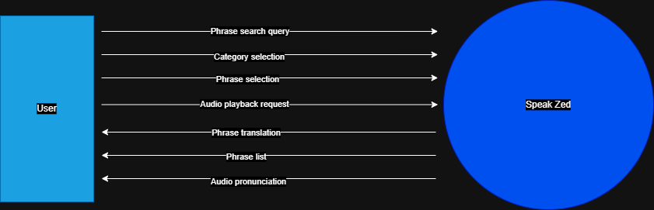
Figure 16: Context diagram of Speak Zed
The context diagram in figure 1 illustrates the interaction between the Speak Zed application and its external entity, the end user. The user interacts with the system through the mobile interface to search for phrases, listen to pronunciations and view translations. For example, a user may select a category and the system returns phrase list of that category through which the user may search for a specific phrase and maybe even request for an audio playback and the system displays the phrase translation and plays the audio pronunciation.

DESIGN METHODS
    - Architectural Design
This section dives into the high-level structure of the system- how the major components of the Speak Zed are organized and how they communicate. It defines:
- The major components of the system.
- How components interact.
- How data flows between the components.
- Where processing happens.
The system adopts a combination of the layered architecture and the component-based architecture.
The layered architecture divides the system into layers, where each layer performs a specific role. The typical layers include:
- Presentation layer- user interface.
- Application/logic layer- system functionality.
- Data layer- storage and retrieval.
This gives a clear separation of responsibilities amongst layers, simplifies maintenance and is already widely used in mobile applications and is therefore ideal for Speak Zed.
The component-based architecture shows the independent modules/components. The main modules in the Speak Zed application include:
- Categorized phrasebook module
- Quiz module
- Search module
- Audio module
- Favorites module
This supports modular design which in turn has the following advantages:
- Flexibility and customization: Modular systems allow for easy modification or reconfiguration of specific components without redesigning the entire product.
- Cost savings and efficiency: Standardized modules can be mass-produced, lowering manufacturing costs. Additionally, faster assembly time reduces overall labor costs.
- Easier maintenance and repair: If a part breaks, you can replace the specific, self-contained module instead of the entire system. This significantly reduces maintenance downtime and costs.
- Improved quality and faster time-to-market: Modules are often manufactured in controlled environments which ensures high quality and consistent testing before on-site assembly.
- Scalability: Systems can be scaled up or down by adding or removing modules, making them highly adaptable to changing demands.
- Sustainability: Modular products often have longer lifespans, and components can be replaced or recycled more easily, reducing overall waste.
With respect to Speak Zed, the component-based architecture promotes flexibility, easier maintenance, cost-efficiency, extensive testing and faster development.
Together, the layered architecture and the component-based architecture form a strong architectural design that support the goal of Speak Zed.
Below is the architectural design of Speak Zed:
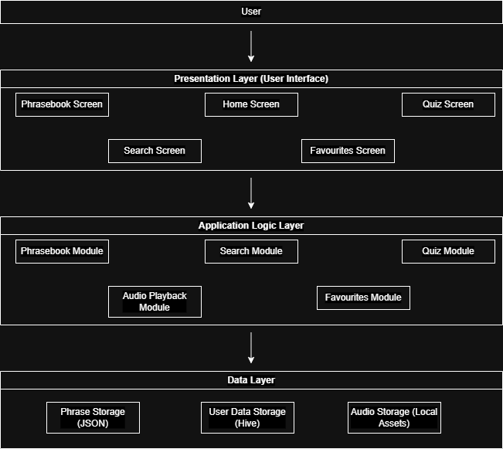
Figure 17: Speak Zed Architectural Design
    - Detailed Design
This is where each module is broken down and explained in more detail to get a better picture of the inner workings of the system.
- Structured Analysis Development
Data flow diagrams were used to show how data flows and how processes interact. No Entity Relational diagrams (ERD) were used because initially, the system uses JSON files and Hive local storages which do not use complex relational tables. Three data flow diagrams were used which include one level 0 data flow diagram and two level 1 diagrams.
The level 0 diagram breaks the system into major processes but still keeps things simple. The system is shown as a whole, highlighting the core processes and how data flows across them.
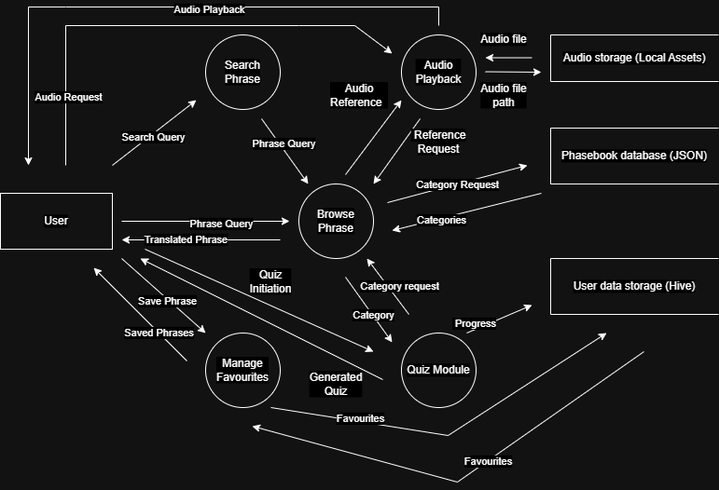
Figure 18: Level 0 Data-flow Diagram
The level 0 diagram above shows the major processes: browse phrasebook, search phrase, audio playback, manage favorites and the quiz module. These processes interact with data stores: Audio storage, phrasebook storage and user data storage.
The reason for three separate storage areas is to promote organized data, so different types of data for different purposes is stored and managed differently. Separating user data from the systems data storages such as the phrasebook storage enhances security of the system and also usability for the user as they have control over their own data and preferences. Audio files are stored in .mp3 format and fit best in the local app assets. For security purposes, only the audio playback process interacts with this particular folder in order to retrieve and play audio files while the phrasebook holds references to the audio files in form of file paths.
Given a scenario where the user chooses to search for a particular phrase for example, the search process interacts with the phrasebook feature that retrieves phrases from data stores and displays them to the user.
Two level 1 diagrams were used to further describe the two processes that proved complex to understand from the level 0 diagram.
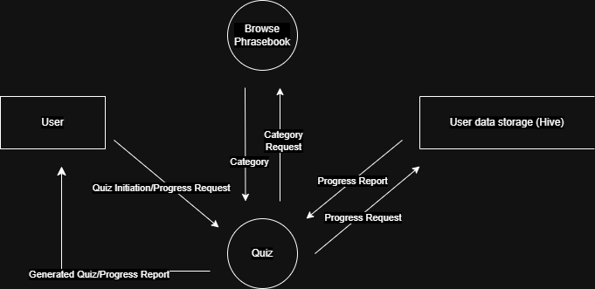
Figure 19: Level 1 Data-flow Diagram for Quiz Module
A user can either initiate a quiz or request for their progress report. When a quiz is initiated, the quiz module interacts with the phrasebook in order to retrieve a category chosen by the user. It then generates questions depending on the difficulty level set and displays the questions to the user who can then take the quiz. The quiz module has a feature that keeps track of progress and at the end of each quiz, this progress is stored in the user data storage and can be retrieved at any time for the user to view.
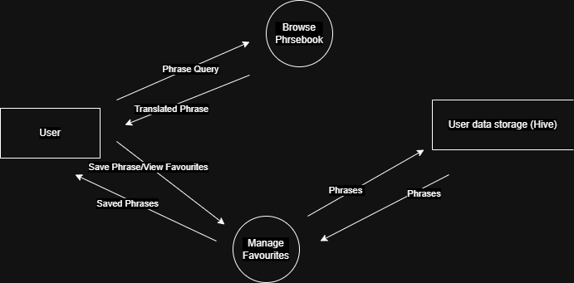
Figure 20: Level 1 Data-flow Diagram for Manage Favorites Process
When interacting with the Manage Favorites process, a user may either add a phrase to their favorites, view their favorites or remove a phrase from their favorites. The remove favorites scenario was excluded from the diagram for simplicity since a user will mostly care about adding and viewing their favorite phrases compared to removing phrases from their favorites.
For a user to add a phrase to their favorites, they need a phrase to begin with, this is why the Browse Phrasebook has been added to the diagram regardless of it having zero interaction with the Manage favorites process. Once a user has a phrase they want to save, they save it to their favorites and the Manage favorites process stores it in the user data storage. When the user wants to view their favorites, the Manage Favorites process retrieves these phrases from the user data storage and displays them to the user.
- Object-Oriented Analysis Development
In this section, use case diagrams, class diagrams and sequence diagrams were used.
The use case diagram below shows what the system should do, capturing functional requirements from the user’s perspective.
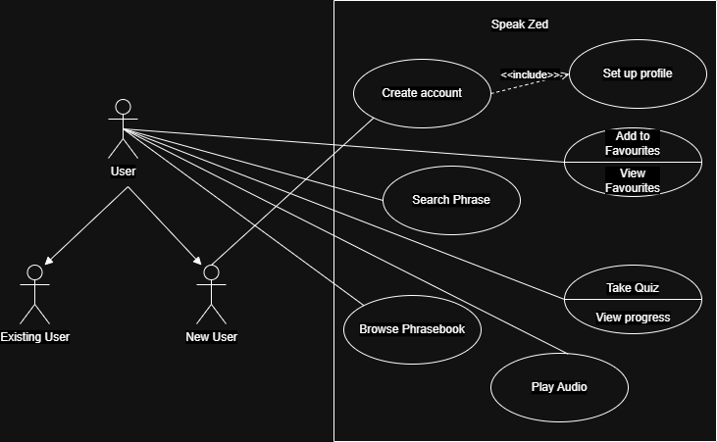
Figure 21: Use case Diagram for Speak Zed
The main actor in this case is the user. Secondary actors were not included because the system does not interact with any secondary actors in order to deliver its functionality. The inheritance on the user shows that the user can either be new or existing. An existing user is one who has used the system at least once and they already have a functional user account. A new user must first create an account and set up a profile in order to use the application. Once an account is created and the profile is set up, the new user becomes an existing user and can use the application. Possible use cases are Browse Phrasebook, Play Audio, Take Quiz, View Progress, Add to Favorites and Search Phrase.
A class diagrams to depict the different classes, their attributes and methods (functions) is shown below:
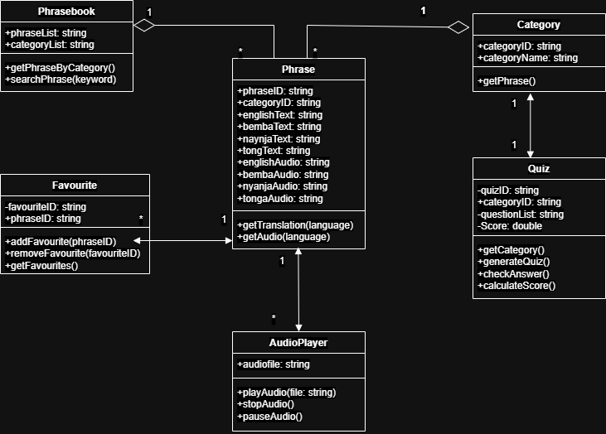
Figure 22: Class Diagram for Speak Zed
Conceptually, the system has six classes namely, Phrasebook, Phrase, Category, Favorite, AudioPlayer and Quiz. Each has attributes methods. Some attributes are private and can only be accessed by the specific class and this is indicated by the ‘-’ sign, while the ‘+’ sign shows that the attribute or method is public. All methods are public to allow for interaction between classes. The data types of the attributes are all strings, including the ID attributes to make it simpler to distinguish ID groups. For example, a phraseID could be “P1” while a categoryID could be “C1”, a favoriteID could be “Fav1” and so on. An aggregation relation is placed between the Phrasebook and Phrase classes because a phrase is part of the phrasebook but can still exist on its own. Similarly with the Category class. The other classes have simple associations because they simply interact. The multiplicities show the following:
- One Phrasebook has multiple Phrases.
- One Category has multiple Phrases.
- One Category has one Quiz.
- One Phrase multiple favorites- due to language variation.
- One phrase has multiple audio files- due to language variations.
Sequence diagrams were then used to show the inner workings of each module. They show the sequence of processes based on a given scenario.
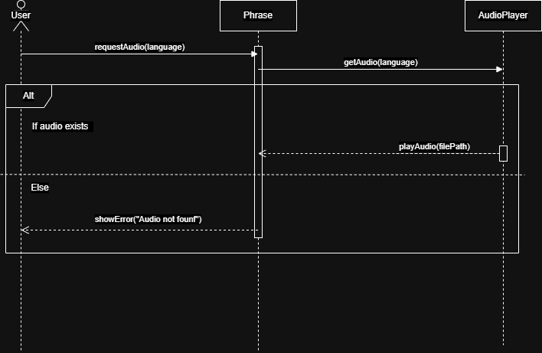
Figure 23: Sequence Diagram for Audio Playback Process
The above sequence diagram shows the sequence of processes that occur in order to play audio. The user is the actor, the objects involved are the Phrase and AudioPlayback. While viewing a phrase, a user request for its audio, the Phrase checks for the audio path for the requested audio from the AudioPlayback. If the audio exists, the AudioPlayback plays the audio, otherwise the Phrase displays an error message to the user, informing them the file does not exist.
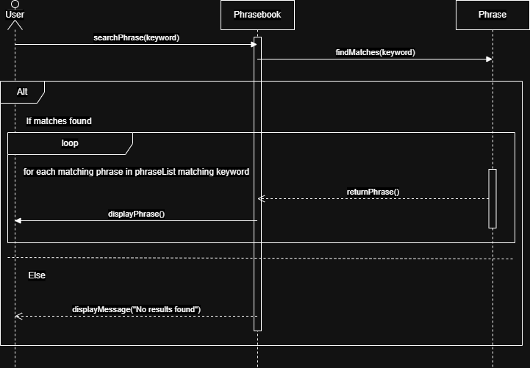
Figure 24: Sequence Diagram for Search Phrase Function
The objects involved in this case are the Phrasebook and Phrase. Search is not an independent object but a functionality present in the Phrasebook. A user enters a keyword and the Phrasebook checks the Phrase to see which one or which ones contain the matching keyword. If matches are found, the system enters a loop in which it retrieves a phrase and displays it to the user but it only does this for phrases that match with the keyword. If no matches are found, a message is displayed to the user telling them that there no results.
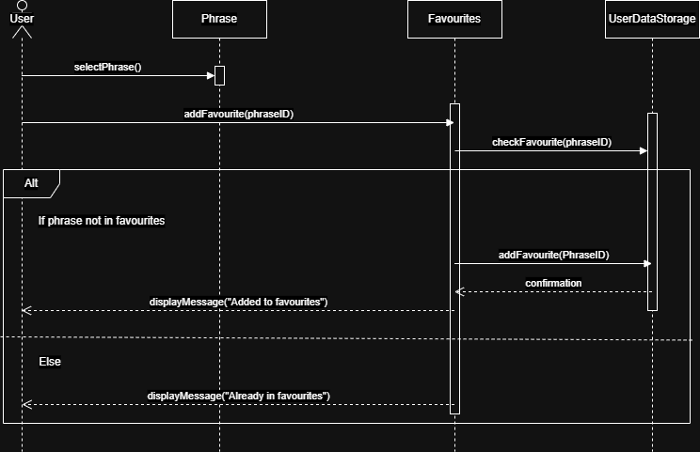
Figure 25: Sequence Diagram for the Favorites feature
The scenario taken in this case is one where the user adds a phrase to their favorites. The objects involved are the Phrase, Favorites and the UserDataStorage. A user first selects a phrase, then they can choose to add it to their favorites. The Favorites object checks the UserDataStorage if the phrase being added already exists. If the phrase is not found in the storage, the phrase is added to the storage and a confirmation message is displayed. Otherwise, a message telling the user the phrase was already added is displayed.
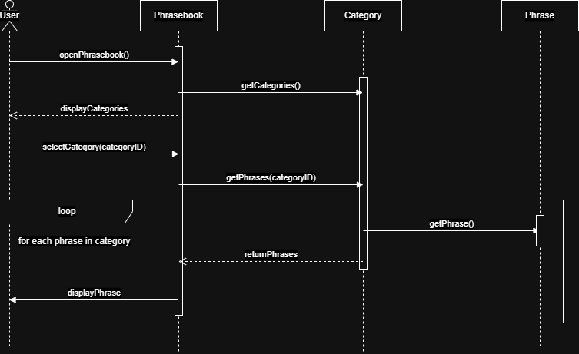
Figure 26: Sequence Diagram for the Phrasebook without the Search function
The objects involved are the Phrasebook, Category and Phrase. A user opens the Phrasebook. The Phrasebook gets the categories and they are displayed to the user. When the user selects the category, the Category enters a loop where it retrieves each phrase in that category and the phrases are displayed.
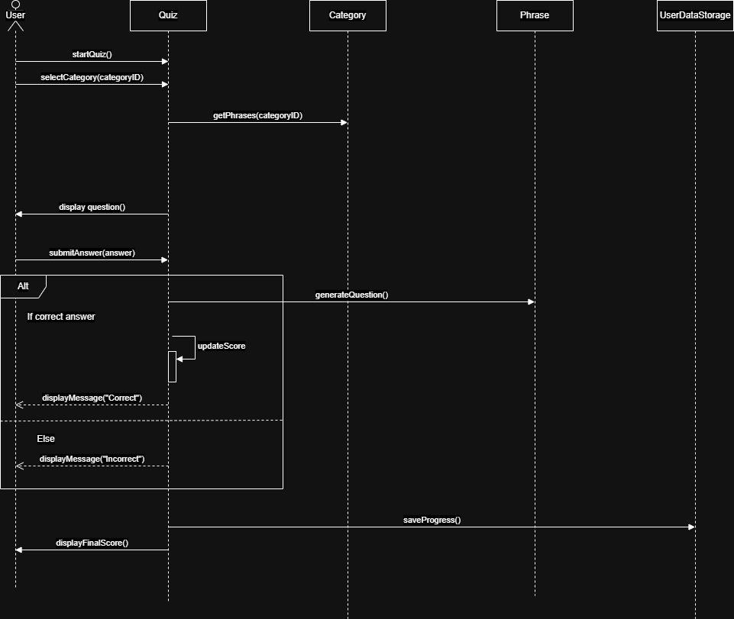
Figure 27: Sequence Diagram for the Quiz Module
The scenario given in this case is the user taking a quiz and the objects involved are the Quiz, Category, Phrase and UserDataStorage. The user initiates a quiz and picks the category they wish to test themselves in. The Quiz gets the category and generates a quiz. A question is displayed to the user who may now submit an answer. The quiz module checks if the phrase is correct by checking the original phrase. If the phrase is correct, it updates the score and displays a message telling the user they are correct. Else, it displays a message telling the user they are wrong. At the end of the quiz, the Quiz saves the progress to the UserDataStorage and displays the final score to the user.
All the diagrams in this section illustrated the processes of the system, how each module interacts with other modules, where data is stored and the sequence of processes in the system.

PHYSICAL DESIGN
    - User Interface Design
The user interface was designed to be as simple and clean as possible. UI mockups were designed to show the initial layout of the screens.
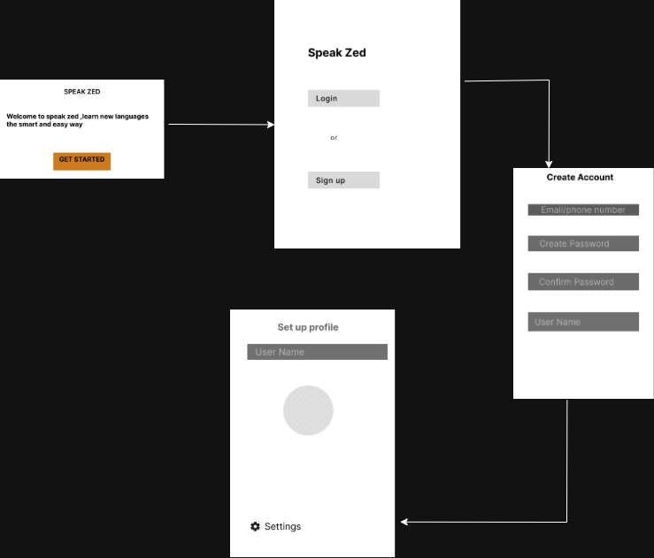
Figure 28: Flow for the first few screens
Once a user opens the application, they first see a welcoming screen. This screen is meant to capture the user’s interest even before they get to the application. After clicking the “Get Started” button, they are given the option to login if they already have an account or sign up if they do not. Suppose the user is new, they will create their account by entering the details specifies in the screen labelled “Create Account”. They can then proceed to set up their profile by either changing their username and adding a profile picture or just sticking to the initial username and adding a profile picture. The settings, in this case, allow them to change details such as the information they specified in the previous screen.
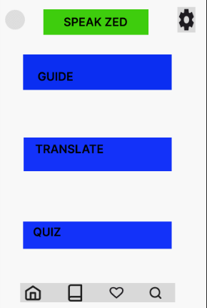
Figure 29: Home screen of Speak Zed
The home screen shown in figure 19 is the first thing the user sees once they are signed in. The settings icon allows them to change application preferences such as whether they prefer a darker theme or a more colorful layout. Although, in early versions of Speak Zed, such a feature is not included and the default remains the lighter theme. The profile icon on the top-left side of the screen enables a user to access their account details and be able to edit profile details as well as decide whether to log out of the application. When clicked, the Guide tab shows the user a short tutorial on how to use the application features. The Translate tab leads to a screen that will be shown further into the document and the same applies for the Quiz tab. The house icon leads to the home screen, the book icon leads to the categorized phrasebook, the heart icon leads to the favorites and the magnifying glass icon leads to the search screen. An icon is highlighted to show which icon is currently active.
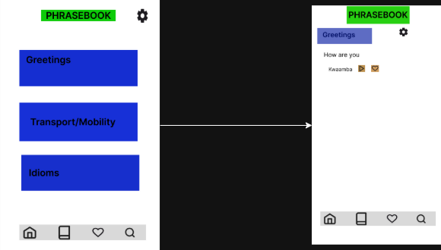
Figure 30: Phrasebook and Categories screens
Figure 20 shows the phrasebook and screen when a user clicks the book icon. It displays the available categories and a user may scroll up or down to view all categories. Once a user clicks on the category, it leads to a page layout such as the one in the screen on the left. The settings icon allows the user to change language preferences. Depending on those settings, the phrase is shown in both the main language and its translation below it. The translation has the play button and favorite button which the user may click to listen to the audio pronunciation or add to their favorites, respectively.
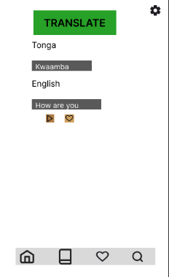
Figure 31: Translate Screen
When a user clicks on the translate tab on the home screen, it leads them to the screen shown in figure 21. A user may then type in a phrase they wish to translate in the master language and a translation of it is shown below. This translation has the same audio and favorite icons with the same function.
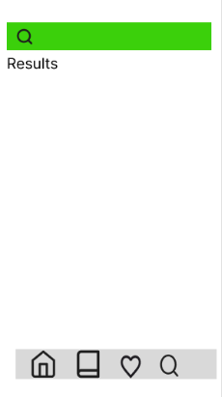
Figure 32: Search Screen
When the user clicks on the magnifying glass icon, it leads them to the search screen shown in figure 22. The search bar is shown in green and results from the search appear below it.
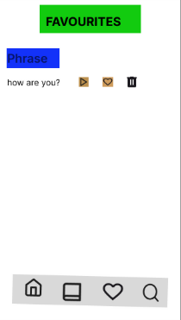
Figure 33: Favorites Screen
Figure 23 shows the screen that displays when the user clicks on the heart icon. It simply displays a list of phrases that were added to favorites. And phrases can be removes from favorites by clicking the bin icon. The play and heart icon maintain the same functionality.
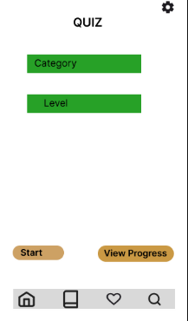
Figure 34: Quiz Screen
Figure 24 shows the Quiz screen which displays when a user clicks on the Quiz tab on the home screen. The settings allow the user to change language preferences. The user must pick a category and specify their level of specialty then click the Start button in order to initiate a quiz. Otherwise, they may view their progress report on the View Progress button.
    - Process Design
- Search Process
When a user enters a search query, the system first validates the input to ensure that it is not empty or invalid. Upon successful validation, the search module processes the query and performs a lookup within the locally stored JSON phrase data. Matching phrases are retrieved based on keyword comparison and are then displayed to the user in a structured list format. This process enables users to quickly locate relevant phrases across multiple supported languages.
- Phrasebook Navigation Process
The phrasebook navigation process allows users to browse phrases based on predefined categories. When a user selects a category, the system retrieves all associated phrases from the JSON storage. These phrases are then presented in a list format within the user interface. Users may select individual phrases to view detailed translations and access additional features such as audio playback. This process supports intuitive exploration of the system’s content without requiring search input.
- Audio Playback Process
When a user selects the audio playback option for a phrase, the system retrieves the corresponding audio file path from the phrase data. The audio playback module then accesses the audio file stored locally within the application’s asset directory. The file is loaded and played through the device’s speaker. This process ensures that users can hear accurate pronunciation of phrases without requiring internet connectivity.
- Favorites Management Process
The favorites management process enables users to save and retrieve frequently used phrases. When a user selects the option to add a phrase to favorites, the system stores the phrase identifier in local storage using Hive. If the phrase is already marked as a favorite, the system may update or remove it accordingly. When the user accesses the favorites screen, the system retrieves the stored identifiers from Hive and matches them with the corresponding phrase data in the JSON storage. The resulting phrases are then displayed to the user.
- Quiz Module Process
The quiz module generates interactive learning activities based on available phrase data. When a user initiates a quiz, the system retrieves a set of phrases from the JSON storage, typically filtered
- Input Validation and Error Handling
The system incorporates basic input validation mechanisms to ensure reliable operation. For example, search inputs are checked for emptiness before processing, and invalid user actions are handled gracefully. Where necessary, the system provides feedback to guide the user, such as prompting for valid input or indicating unavailable results.
The process design of the Speak Zed system ensures efficient handling of user interactions through clearly defined functional modules. By leveraging locally stored data and structured processing workflows, the system delivers responsive and reliable performance while maintaining its offline-first design.
    - Data Modelling and Storage
- Overview of Data Types
The Speak Zed system utilizes three primary categories of data: phrase data, user data, and audio data. Each category serves a distinct purpose within the system and is managed using appropriate storage mechanisms to support the system’s offline-first functionality.
Phrase data forms the core of the application and includes multilingual translations and associated metadata. User data captures dynamic interactions such as saved favorites and language preferences. Audio data consists of pronunciation files that enhance the learning experience.
- Data Structure
- Phrase Data Structure (JSON Format)
Phrase data is stored in JavaScript Object Notation (JSON) format, which provides a lightweight and structured method for representing multilingual data. Each phrase entry contains an identifier, category, translations, and references to audio files.
An example of the JSON structure is shown below:
Table 1: Structure of Phrase Data
{
"phraseId": 1,
"category": "Greetings",
"translations": {
"English": "Hello",
"Bemba": "Shani",
"Nyanja": "Moni",
"Tonga": "Muli buti"
},
"audioPaths": {
"English": "assets/audio/en/hello.mp3",
"Bemba": "assets/audio/bm/hello.mp3"
}
}

The structure of the phrase data is summarized in table 1 below:

Table 2: Structure of phrase data
Field | Data Type | Description
phraseID | String | Unique identifier for each phrase
category | String | Classification of phrase, for example, Greetings
translations | Object | Stores translations across supported languages
audioPaths | Object | Stores file paths to corresponding audio files

This structure allows efficient retrieval of multilingual content while maintaining a clear relationship between textual and audio data.
- Storage Mechanisms
- Phrase Data Storage (JSON)
Phrase data is stored locally within the application in JSON format. This data is static and read-only during runtime, ensuring fast access and consistent performance without requiring internet connectivity.
- User Data Storage (Hive)
Dynamic user data is stored using Hive, a lightweight local storage solution. Hive is used to persist:
- User preferences, such as default language settings. This enables the system to retain user-specific configurations across sessions while maintaining efficient read and write operations.
- Favorite phrases selected by users
- Audio Data Storage (Local Assets)
Audio files are stored locally within the application’s asset directory. These files are organized by language and referenced through file paths defined in the phrase data.
By separating audio storage from structured data, the system ensures efficient handling of multimedia content while maintaining a lightweight data model.
- Data Relationships and Access
The different data components in the system are interconnected to support application functionality. Phrase data contains references to audio files, enabling the audio playback module to retrieve and play the appropriate pronunciation. User data stored in Hive references phrase identifiers to maintain a list of favorite phrases.
The application logic layer mediates access to all data sources. When a user interacts with the system, the relevant module retrieves data from either the JSON storage or Hive, processes it, and presents it through the user interface.
The data modelling approach adopted in the Speak Zed system ensures a clear separation between static, dynamic, and multimedia data. By utilizing JSON for phrase data, Hive for user data, and local storage for audio files, the system achieves efficiency, scalability, and full offline functionality.

CONCLUSION
This chapter presents the comprehensive design of the Speak Zed system, detailing the structural and functional aspects necessary for its development. The system design incorporated multiple modelling approaches, including data flow diagrams, object-oriented design models, and architectural design, to provide a clear and systematic representation of the system.
The use of data flow diagrams enabled the visualization of how data moves within the system, while object-oriented models such as use case, class, and sequence diagrams provided insight into system interactions and relationships among components. The architectural design further established a layered structure that separates the presentation, application logic, and data management components, thereby promoting modularity and maintainability.
In addition, the physical design translated the abstract models into practical implementation details, including user interface mockups, data modelling, storage mechanisms, and process workflows. These elements collectively ensure that the system is not only functionally sound but also user-centered and aligned with the identified requirements.
Overall, the design decisions made in this chapter support the development of an efficient, scalable, and offline-capable application. The Speak Zed system is therefore well-positioned to address the communication challenges identified in earlier chapters, while providing a robust foundation for implementation and future enhancements.

